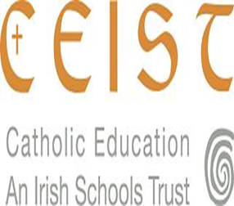

Annual Report 2014/2015
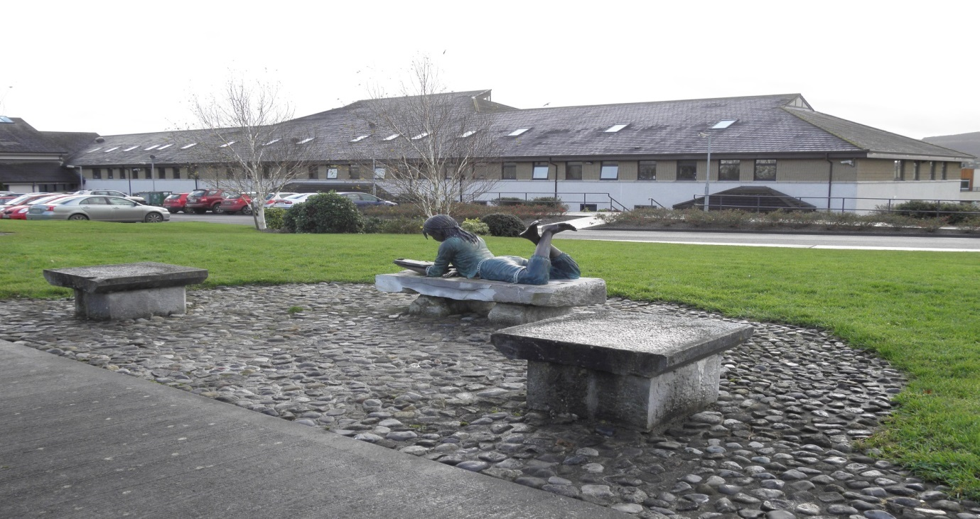

ST. MARY’S SECONDARY SCHOOL
MALLOW, CO. CORK.

Telephone: 022-21998 Email: info@stmarysmallow.com
Fax: 022-21829 www.stmarysmallow.com
@stmarysmallow

TABLE OF CONTENTS

- Mission Statement
- School Awards Ceremony
- Faith Development
- School Development Planning
- Pastoral Care
- Special Needs Education
- Educational Supports
- School and Extra-Curricular Activities
- Continuous Professional Development
- Student Council Report
- Parental Involvement
- Report from the Chairperson of the Board of Management
- Enrolment

- Mission Statement

St. Mary’s Secondary School, Mallow is a voluntary Catholic secondary school under the trusteeship of CEIST.

In co-operation with the Department of Education, with parental and community support and within the available resources our mission is:

To develop a community of learning which is geared towards the holistic development of each student;

To foster the pursuit of academic excellence, respecting the specific potential and talents of each student;

To promote within the school community the values of a Christian, caring society;

To value, within the total school community, self-respect, respect for others and for the environment;

To recognise and affirm the unique value and contribution of each individual.

- School Awards Ceremony

The 2014-2015 school year ended with a positive celebration of student achievement at the annual School Awards Ceremony on Monday 18th May 2015 with guest speaker Dr. Marie Griffin C.E.O., CEIST. The Student Council was also represented on the day and addressed the school community gathered together for the celebration of student achievement in the academic year 2014-2015.

Attendance
The first awards of the day were presented for attendance recognising the value of the daily grind in school forming the building blocks of future successes. 17 students received an attendance certificate for full attendance during the academic year 2014-2015.
Ellen Murphy – 1st year
Adesola Ayodele, Caoimhe Cronin. Lean Duane, Aoife Fitzpatrick, Leah McCarthy Cahill, Eibhlis Myers, Brid O Keefe, Laura O Shea – 2nd year
Aoife Cronin, Laura Kilmartin, Grace Moloney – 3rd year
Aoife Browne – TY
Emma Anunobi, Jane Hyde – 5th year
Joanne Moloney, Aoife Walsh – 6th year

PE and SPORTS AWARDS
This section of the Awards Ceremony acknowledges not only success in sport during the year but also the participation of students in the area of PE in St. Mary’s. Louise Heavin, head of the PE Department presented these awards and recognised the plethora of activities the students are involved in. Orienteering in Doneraile Park, a hugely successful Health Week linking positive mental health with physical activity, the Cork Ladies Mini-Marathon, the Aviva Fitness challenge were just a few of the events that were undertaken by students in St Mary’s during the year.
Junior PE Award:
For participation and voluteerism: Lauren Hadden
Senior PE Award:
For enthusiasm and motivation: Mickela Roche
Basketball:
St Mary’s had four basketball teams representing the school in the South Regional League. The captain of each team – Serena Amechi Minor Team, Lean Duane Junior Team, Emily Brosnan Cadette Team and Maeve O Sullivan Senior Team – were presented with an award to share with the team in recognition of their dedication to training and their participation in the sport.
Other Sports
Louise Heavin highlighted for the school community that among the student cohort in St Mary’s there are champion badminton players, cyclists, boxers and horse riders. There are students on the Cork Ladies Football and Camogie teams as well as athletes training with the Irish Tethrathlon Squad. As well as that there are international swimmers, gymnasts and students playing on the Munster ladies Rugby squad. Congratulations were extended to all involved in sport at any level: School, Club, County or International.
Tennis:
Three teams represented the school in the Munster Schools Tennis Competition. Each team received an award to share in acknowledgement of their participation in the competition.
U14 Team – Leah McCarthy Cahill
U16 Team – Eve Donnelly
U19 Team – Evelyn O Keefe
Orienteering
We had another very successful year in the schools orienteering schools and championships with many of our competitors picking up medal. Our second year /third year team once again regained their All Ireland Schools title when they participated in the final in Castlecomer, Co Kilkenny.
- Eimear Aherne
- Hannah Gayer
- Abbey Lucey
- Alli Fitzpatrick
Camogie
The 2014-2015 year was a very successful year for the camogie teams in the school. At the beginning of the season the Intermediate camogie team won the County Final beating Crosshaven at the Cork Camogie grounds in Castle Road.
The year finished on a high note with the First Year Camogie Team winning the county final in recent weeks.
First Year camogie award:
For dedication and improvement: Ella O Sullivan
Junior Camogie Player award:
For talent and hard work, a love of sport and dedication to school and club: Mai Willis
Senior Camogie Player award:
For immense talent and dedication, for a positive attitude on and off the pitch, for her enthusiasm and encouragement of others: Aoife Sheehan

Football:
St Mary’s has a large number of hugely successful footballers, at the awards ceremony we recgonised the students who recently represented Cork in an All Ireland Football U14 blitz – Ciara O Callaghan, Ciara Lawlee, Ellie Jack, Mairead O Sullivan, Jessica Barrett, Aisling Sheehan.
Footballer of the year:
Despite a defeat this footballer came on the in the Munster final to score a goal – Aisling Healy
Overall sports award:
The overall sports award went to a student who has great sporting talent . She has worn many jerseys and leotards here in St Mary’s. Michelle Nagle

MUSICAL INTERLUDE - The talent in St Mary’s extends to all facets of life and a violin solo from 6th year student Eleanor Rutherford led us to the next section of the awards ceremony where students were recognised for their ability and participation across the diverse curriculum in St Mary’s.

Gaeilge
An Chéad Bhliain – Gradam na Gaeilge
Is sárscoláire í an cailín seo. Déaann sí tréan iarracht i gconaí ar son na Gaeilge. Bíonn sí ag labhairt agus ag spreagadh an teanga gach lá, ní hamháin sa seomra ranga. Oibríonn sí go dian agus tá ard caighdeán Gaeilge aici. Chomh maith le sin is cailín dea- bhéasach agus cabhrach í. Is Ambasadóir na Gaeilge í gan dabht. - Hannah Nic Gearailt
Coiste Gaelach – D’oibrigh an grúpa seo go dian ar son na Gaeilge i rith na mbliana. Faigheann said gradam inniu le roinnt idir eatarthu. Lean ar aghaidh leis an obair a chailíní.
Geography
For academic improvement, engagement in Geography, in recognition of her work in school recycling and the Green Schools Committtee – Chloe Hallissey
History
Contribution to History Award
For diligence, positive attitude and consistently high standard of work – Hannah Gayer
Senior History Award
As we approach the centenary of the 1916 Rising St Mary’s has chosen to adopt Elizabeth O Farrell, the nurse who carried messages from the GPO for particular attention. This year we introduce the Elizabeth O Farrell Senior History award which is a perpetual trophy.
For their curiosity and passion about history, for effective and balanced arguments, for their kind and generous spirits – Rachel Moore and Caoimhe O’Brien.

French
First place in the school’s French quiz – Jennifer Owens, Monica Dumitriu, Jane Hyde, Niamh Sheehy
Second Place – Lauren O Grady, Tia Crean, Laura Fitzpatrick
German
Junior German Award – Sarah Corbett and Rachel Wharton
Senior German Award –Eleanor Rutherford.
Spanish
For embracing learning the language and enthusiasm for tasks – LCA2 Spanish award – Shania Griffin
Japanese
For her hard work and diligence, for excellent attendance and fully completed homework – Erica Daly
Business
For her diligence and participation in class – First Year Business award – Clodagh Hickey
First place in the Regional Finals of the Junior Cert Business Quiz, representing St Mary’s in the National Finals – Sarah Corbett, Kate Ivory, Ciara McCarthy, Lauren Hadden
2nd year Business Enterprise Candy Crew – This was an enterprise that worked after school and they reaped the rewards when they won the Local Enterprise Board’s regional Final in the Intermediate Category and represented St Mary’s in the National Finals in Croke Park – Adesola Ayodele, Leah McCarthy Cahill, Hannah O Flaherty, Aisling Gleeson, Laura O Mullane.
Home Economics
Junior Home Economics award – for dedication to the subject and outstanding practical work in both craft and cookery – Ruth Curtin, Rachel Wharton and Sally Murphy
Senior Home Economics award - for consistent dedication to the subject throughout her six years in St Mary’s, displaying flair of the subject as well as a positive attitude to the subject in both craft and cookery – Aoife Walsh

Art
First Year Art
First Year Art provides an opportunity to explore many disciplines. This student has used this opportunity to use her creative abilities to achieve high standards. Aoife Lee
Second Year Art
A modest talented student who has worked extremely hard to achieve creative excellence – Ella Doolan
Third Year Art
This student has worked consistently throughout the year developing her concepts which resulted in strong realisation of her ideas – Carla Bull
Fifth Year Art
A student who embraces the challenges of Senior Art, developing an individual interpretation, she is extremely talented and creative – Kayleigh Green

CEIST Perpetual Trophy Award Design
Earlier in the school year Art students were invited by our Trustees CEIST to design a perpetual award which would embody the spirit and values of CEIST. This student embraced this brief, her design was entered into the competition. Today we wish to take this opportunity to acknowledge her contribution. – Lainey Coroon
LCA 2 Art
LCA 2 art is a wonderful mix of many Art Craft and Design Disciplines. Encouraging students to think in a creative way while developing confidence and an appreciation of the visual world. This student has fulfilled this philosophy working with initiative and maturity. – Lynn O Keefe
Leaving Cert Art
A student who has remained focused throughout the two years of senior art, working to achieve quality in her approach to the history of art and visual creativity. – Emer O Connor
Maths
For her dedication and excellent attendance the Maths Club student of the year is Amy Sheehan.

Music
Music is an intrinsic part of life here in St Mary’s. As we have heard today many of our students have talents that they share so willingly with us and we listen with pride to that musical talent when we are gathered together as a school community. In each year there are students who show themselves not only to be talented musically but who embrace the learning that goes with developing a talent and continue to excel in their musical abilities.
1st year – Hannah Fitzgerald, 2nd year – Aoife Fitzpatrick, 3rd year – Rose Doyle
5th year – Kayleigh Thornhill, 6th year – Fiona Long
MUSICAL INTERLUDE To showcase the talent we celebrated our senior choir comprised mainly of 6th years who were coming to the end of their tenure in St Mary’s performed for us.
Catherine McAuley Award
The Catherine McAuley award honours the memory of the founder of the Mercy Order and recognises the qualities of kindness, generosity of spirit, self-motivation, striving to help others, community involvement in one of our students. This year’s recipient has proven to have all of these qualities through her involvement with CEIST student leadership, St Vincent de Paul, Green Schools and giving of her time to help families by refurbishing a family waiting room in the Mercy Hospital Cork. Emma O Callaghan, 5th year is this year’s very deserving winner of the Catherine McAuley Award.
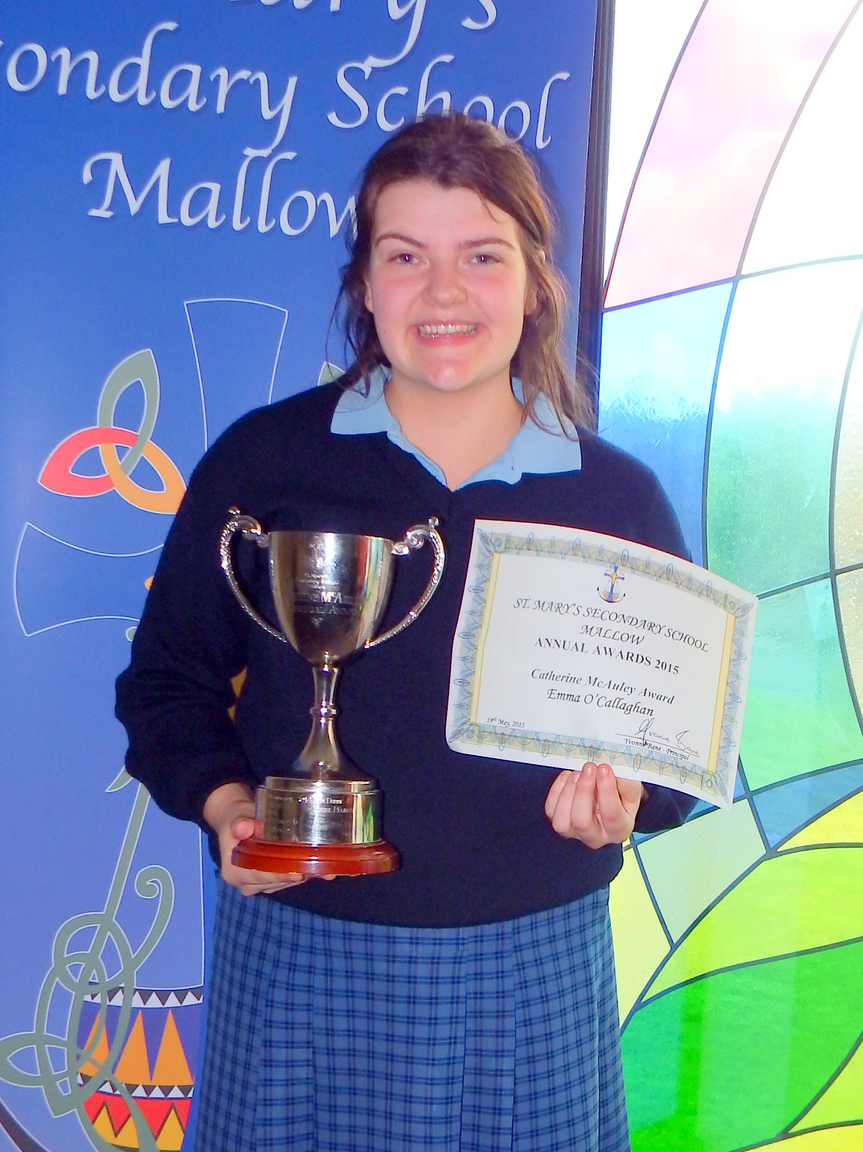

Special Recognition Award –
This award went to a student whose positivity and determination we all admire. Over the past year she has overcome many obstacles and at the awards ceremony her classmates paid tribute to her fighting spirit and perseverance with a special recognition award. Mairead Fouhy
GAISCE
Three students received their bronze Gaisce awards. This involved completing challenges in Community Involvement, a personal skill, a Physical activity and an Adventure Challenge. Their commitment and dedication earned them Bronze Gaisce awards.
Laura Fitzpatrick, Jane Hyde, Aoife Nunan
Green flag awards:
This award went to a collective of years, which came together under one committee for the environmental benefit of the school. They showed great commitment and determination throughout the year in their initiative to get the first ever green flag for the school.
1st years: Abby Buckley, Muirne Clarke, Rebecca Mulcahy
2nd years: Kerrie Loyd, Leah McCarthy Cahill, Natasha Cambridge
TY: Aisling Murphy, Aisling O Sullivan, Abilgail O Regan
5th years: Jolene Forde, Veronica O Mahony, Jane Hyde, Emma O’Callaghan, Niamh Cronin
Rang Reiltin: Laura O Shea, Lisa Carey, Katie Dinan, Deirdre Glynn
6th year: Catherine Blake

Vincent de Paul
Every Wednesday from December 2014, 8 fifth year students worked for an hour after school as a Junior Vincent de Paul Conference. Their work involved helping with the Homewrok Club, working in the Vincent de Paul Ship, visiting the residents in Brid haven Nursing Home and helping the local senior Conference with their fundraising. They also helped the TYs in fundraising for their Build a Bank Project. Well done to Teja Kaare, Caoimhe Sheehan, Jessica Sheehan, Rachel O Connell, Chloe Linehan, Monica Dumitriu, Emily Falvey and Emma O Callaghan. Emily Falvey accepted Certs awarded to the group at the recent Vincent De Paul Peace and Justice Exhibition in Rochestown Park.

STUDENTS OF THE YEAR

First year student – Rebecca Mulcahy
Second year student – Hannah O Flaherty
Third year student – Sarah Corbett
Rang Reiltin – Lisa Carey
Fifth Year – Fiona Sheahan
LCA 1 – Mickela Roche
LCA 2 – Ciara O Hanlon

SPIRIT of CEIST Award
This year our trustees Ceist have launched the perpetual spirit of Ceist Award. This award recognises student participation and achievement that reflect the five values of the Ceist charter. Promoting spiritual and Human development, Achieving Quality in Teaching and Learning, Showing Respect for Every Person, Creating Community and Being Just and Responsible.
This student is always pleasant and helpful to everyone in her year. She is described as caring and approachable. The Spirit of Ceist Award goes to Helina Debebe.

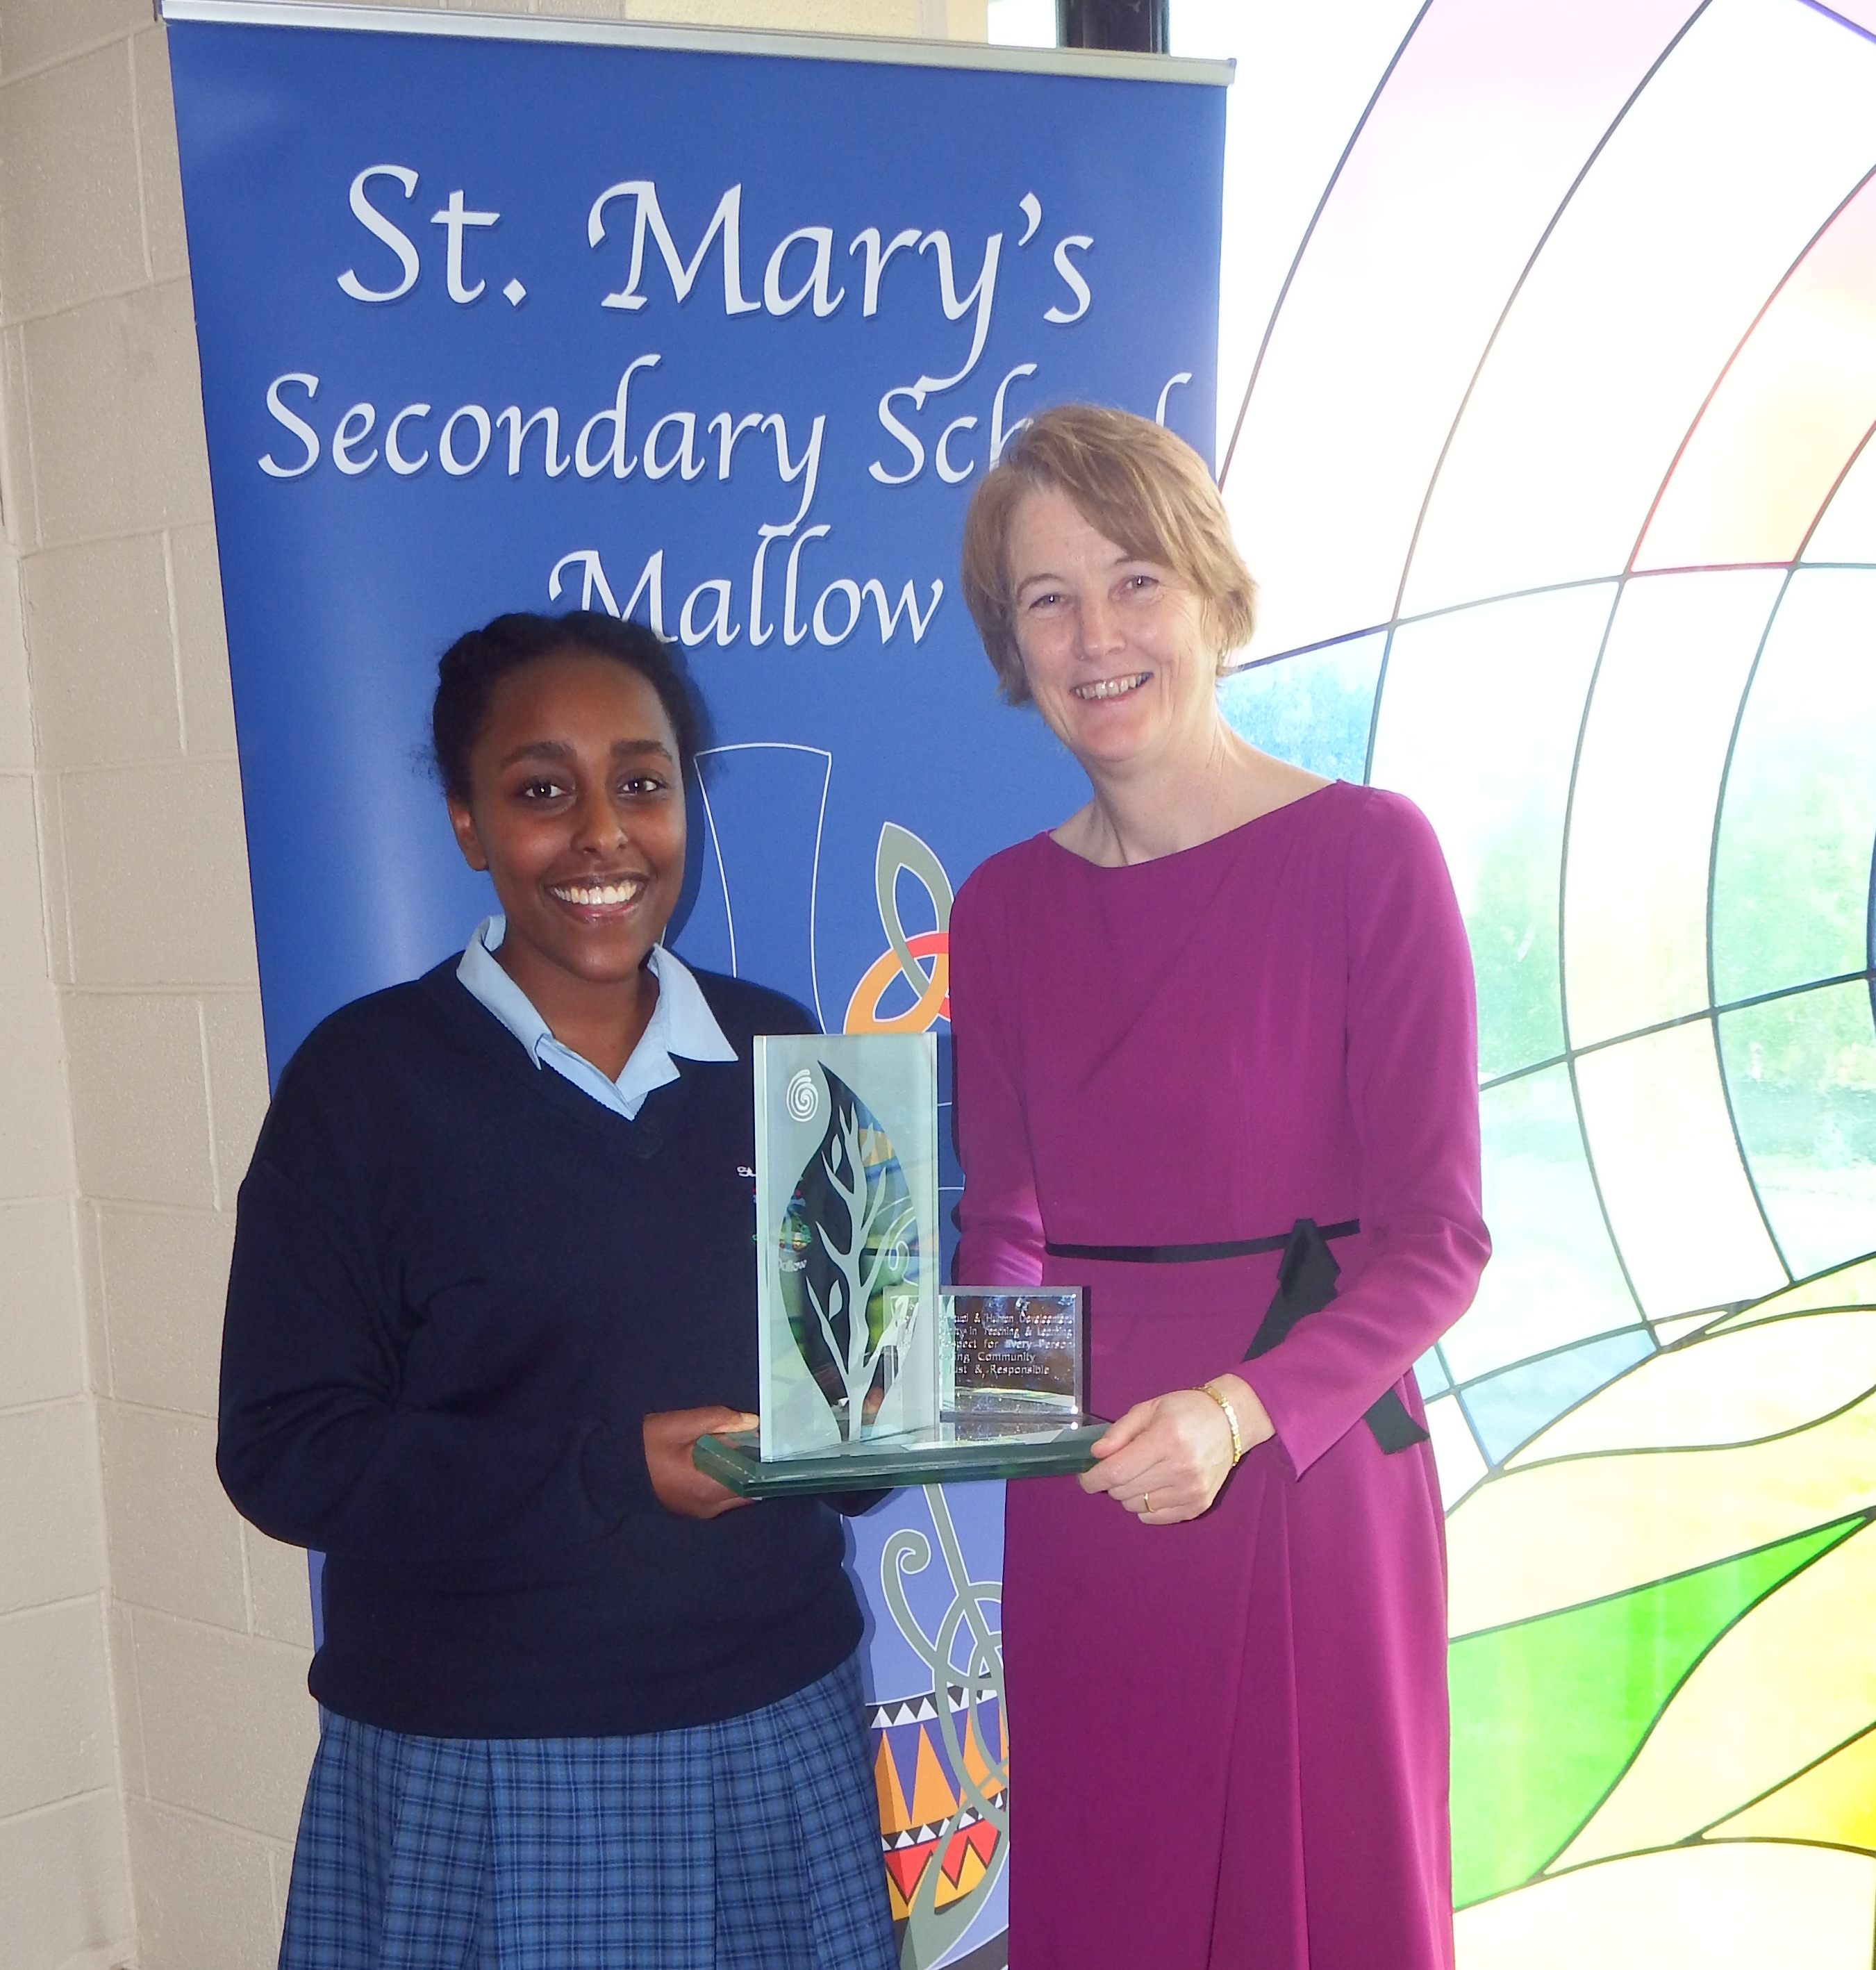

Student of the Year 2015 –
For her work ethic, achievement, kindness, compassion and positivity: the Leaving Certificate Student of the year 2014/2015 was presented to: Máire Murphy.

- Faith Development

St. Mary’s recognises the importance the role of prayer has in the lives of young people and takes the responsibility of creating an atmosphere of prayer and spirituality very seriously.
Faith development is central to the experience of all students in St.Mary’s. The challenges of faith development in a modern society are met in the school by a dynamic RE department that ensures the promotion of Christian values as stated in the school’s mission statement.

To guide students on their faith journey all classes have 3 RE periods per week and the teachers of Senior RE meet for one timetabled class period for subject planning.

A culture of prayer and sacramental life in the school is developed through the prominent displays throughout the school. We have a unique sacred space in our Tearmann. Icons and statues remind the students and teachers of our ethos. Displays for Autumn, November, Thanksgiving, Christmas, St Patrick, Catherine McAuley, Lent are developed by the RE Department in a central space in the building that students pass regularly during the school day. Classes also visit the chapel in the convent adjacent to the school.

St Mary’s observes the events of the liturgical year within the academic year in a variety of reflective ways.
- Mass to celebrate the beginning of the school year and the Mercy Feast Day on September 24th
- Remembrance Mass for the deceased members of our school community and the deceased family members of those in our school community on 20th November 2014
- Year group and class group masses as required – 13th May 2015 (Leaving Cert Graduation Mass)
- Advent Reconciliation Services – Junior and Senior 6th December 2013
- Carol Services and Carol singing fundraising for St Vincent de Paul – 12th December 2013
- Lenten observance and distribution of Ashes
- Sacrament of Reconciliation during Lent

All students have an opportunity to spend time and meditate in the Tearmann for one RE period a week. Students continue to indicate how much they enjoy meditation and teachers are encouraged to train in this area, with many of our RE teachers already trained.
On special occasions our intercom is used to allow our students lead their fellow students in prayer such as Catholic Schools Week.

To allow students time for reflection, meditation and communication with their peers all year groups are given an opportunity to attend a retreat. Taking cognisance of the age profile of the year group different retreats are organised as appropriate.

Visiting Retreat leaders – Gerry Keegan/Declan Browne
Mir Centre – Lombardstown
Nano Nagle Centre – Killavullen
Knock Pilgrimmage
Waterloo Church

10th October 2014 – 5th year
9th October 2014 – 1st year
10th October 2014 – 3rd year
26th September 2014– 6th year
13th February 2014 – 2nd year
20th May 2015 - TY

Student feedback on the retreats for 2014-2015 was very positive with over 95% participation. Students of different faiths use the opportunity for reflection in their own faith under parental guidance.

Chaplaincy

St Mary’s does not have a full time chaplain but we are supported by Fr Micheál Leader for the celebration of Mass, Sacrament of Reconciliation, Lenten and Advent Services.

Ongoing Professional Development

The RE team and Principal met with the Diocesan Advisor on his visit to the school on the 22nd October 2014 to share resources and experiences. Three RE teachers attended the Diocesan Inservice and the RE team is in the contact list for ongoing information and up to date resources from Fr Gerard Condon Diocesan Advisor. The school management facilitates the opportunity for Senior RE teachers to attend the pilgrimage to Knock.

- School Development and School Improvement Planning

The SDP Team for 2014/2015 was Jennifer Hickey, Rory Coote, Connie Curtin, Una Griffin, Valerie O Regan, Kathy McGlade, Niamh Murphy and Yvonne Bane. The development of teaching and learning is closely entwined with school planning in St Mary’s and has been an ongoing process for a number of years involving the whole staff body as well as the school planning team. School planning takes a collaborative approach in St Mary’s and allows for policies to be embedded in school practice. Members of the school planning team are actively engaged in their own CPD to ensure up to date access to information on teaching and learning in the 2nd level sector. Senior Management also ensure that every opportunity is provided for all staff to attend CPD. This team developed an Action Plan for the 2014/2015 year by reviewing the previous year’s planning developments and areas for development as highlighted by staff.
The areas of priority for the 2014/2015 year were:

- Planning for School Open /Day
- Development of the School Improvement Plan for Literacy arising from the SSE process 2014-2015
- Review of Entrance Assessment and introduction of Psychometric Testing for incoming 1st years
- To begin the School Self Evaluation process for Numeracy through continuous professional development. (Rory Coote, Úna Griffin and Valerie O Regan attended PDST inservice in this area)
- Planning for Staff Development session in the area of Numeracy for August 2015.
- Review of School Code of Behaviour particularly sanctions in conjunction with Year Head team.
- Planning for Subject Department Meetings with Literacy items on Agenda
- Senior Courses and Options Parent and Student Information Night
- School Awards Ceremony
- School Planning team attendance at Network of School Planners Annual Conference – Valerie O Regan and Úna Griffin

- Pastoral Care

Pastoral care is at the forefront of our school community. The staff and students work together in ensuring our students are managing well. A number of structures support pastoral care within the school.
It begins from the moment the student enrolls in First Year with individual meetings organised with parents. First Year induction was held on the 25th August 2014. The First Years were the only students present on that day. The programme of induction is led by Emer Hallihan who coordinates a core group of teachers to deliver this programme. Year group assembly is one hour and this is followed by half hour structured sessions (four in total) covering timetables, school diary and lockers, school building layout, getting to know one another activities. Fifth year students take on a leadership role in this process through our Mentor Programme. For the 2014-2015 year 18 students received outreach training from La Scala, Cork (September 2014) to undertake this leadership programme. The mentors meet with the First Years on a weekly basis throughout the year.

Each Junior class is assigned a Class Tutor who meets them as a class group for a subject.
Each Year Group has a Year Head. For 2014-2015 these were:
1st Year : Noirin O Leary
2nd Year: Pauline Cudmore
3rd Year: Ann Cronin
TY: Mary Higgins
5th Year: Mary O Keefe
6th Year: Jill Mullins
LCA: Sr Anne Maria O Carroll
Class Tutors and Year Heads pay a pivotal role in the pastoral care of our students. They liaise with subject teachers/management/parents where the need arises. This is supported by a weekly Pastoral Care meeting timetabled to allow students of concern to be supported and what areas of support to be provided. This meeting was held on Wednesdays at 11.45-12.25 for the 2014-2015 year. A timetabled Year Head meeting was also introduced in the school year 2014-2015. This allowed the Year Heads along with the Principal and the Deputy Principal to meet on a weekly basis on Mondays at 11.45-12.25.

St Mary’s was saddened by the death of Karen Buckley Leaving Certificate class 2009 and in her memory and in support of the school community a whole school prayer service was organised in memory of Karen R.I.P. Catherine McCormack from CEIST attended the service led by the RE Department and the Principal Yvonne Bane.

The pastoral care of staff is paramount to the positive teaching and learning environment that permeates St Mary’s. Staff members are presented with the CPD opportunities that arise throughout the year and are facilitated to attend as is evident from the long list of inservice undertaken by staff in 2014-2015. Support for each other is very strong in St Mary’s and is evident in the collaborative nature of work within subject departments and cross curricular through the TY programme, LCA programme, LCVP programme and the various sporting activities etc.

- Special Needs Education

Number of Special Education teachers in the school - 1
Number of Learning Support Teachers – 1
Special Needs Assistants – 3.5
Number of students in receipt of learning support education – 27

These students were supported with a reduced curriculum in 2nd and 3rd year. German classes in First Year were co timetabled to allow for the provision of additional learning supports. Those with an exemption in Irish or for whom English is a second language were given extra learning support in English and Maths at Irish time.

Number of students with Special Needs – 17 (low incidence)

The provision made for these students included the placement of 4 students in Special Class Réiltín full time and the remainder are integrated into mainstream classes to enable them to take some subjects at Junior Cert. The students for whom resource hours were allocated were on reduced curriculum. Others who in previous years came under High Incidence came within the general allocation and were catered for in Learning Support or in non-Irish classes (if they had an exemption from Irish)

The 2014/2015 year brought some changes to the curriculum in the Special Class after review by the Learning Support teacher, Guidance Counselor with Senior Management. The class is now known as Class Réiltín. There were significant changes in the timetable for these students to broaden the range of subjects taught, to integrate with other students through for example, Music, Photography and Drama. All members of the SNA team have an involvement with Class Réiltín.

- Educational Supports

Number of Travellers - 6
Number of Foreign Nationals- 55
Number of students assessed by psychologists as having Emotional/Behavioural Difficulties - 2
Newcomer students - 5
Disadvantaged students - 80

In ensuring a positive school experience and student access to all elements of the learning experience, St Mary's supports students from an economically disadvanaged background in a number of ways.

The support is extended to these students in the following ways:
- The administration of the DES Book Grant
- The financial assistance of the Society of St Vincent de Paul (4,000 euro was donated to the school in the 2014-2015 year and this was used to pay for school related activities for students in need of support to attend retreats, games, concerts, TY activities, bus trips, and for lunches, supervised study, counselling etc where it was most needed by students.)

The school carefully examines the curricular provision for disadvantaged students and their needs are catered through areas as necessary:

- Learning Support
- Resource hours when approved
- Banding in 2nd and 3rd year for English, Irish and Maths
- Lower numbers in classes where possible
- Supervised Study financed by St Vincent de Paul
- Liaising with NEWB Officer re attendance
- Contact with Medical Personnel
- Meeting Social Workers
- Attendance at Case/Family Conferences
- Leaving Cert Applied Programme provided in the school
- Homework Club 2 evenings a week
- Maths Club – 1 evening a week
- Weekly timetabled Pastoral Care meeting

- School and Extra Curricular Activities:

New learning situations through a host of extra-curricular activities allow each student to reach their potential and develop our community of learning which is geared towards the holistic development of each student. These activities also affirm the unique value and contribution of each individual in our community as laid down in our school’s mission statement.
Students are encouraged and supported to be involved in a broad variety of extra-curricular activities. These opportunities provide the student with new learning situations and the chance to further develop skills to ensure each student reaches their potential.
During the academic year 2014-2015 these included but were not limited to:

TERM 1:

4/9/2014– LCA Outdoor Pursuits – Ballyhass Lakes
8/9/2014 – 6th year Geography Field trip – Rossbeigh Co Kerry
10/9/2014 – 6th year Geography Field trip – Youghal Co Cork
10/9/2014 – Junior Certificate 2014 results
16/9/2014 – 6th year Biology Trip
6th October 2014 – 10th October 2014 – Health Week
7/10/2014 – Psychiatric Nurse talk to 6th years and LCA students as part of Health Week
10/10/2014 – Apprentice Chef Demo in the school – prize as part of winning Apprentice Chef Competition in April 2014.
12/10/2014– UL Maths and Science Fair in Carrigoon, Mallow – School stand with student input under the guidance of the Science Department- Health and the Body as connected to school Health Week 6th – 10th October
14/10/2014 – 5th years attend the Careers Exhibition in the Rochestown Park Hotel in Cork.
15/10/2014 – Brass Quartet session with Music students in the Aemilian Theatre
17/10/2014 – TY RE and History Tour – Dublin
19/10/2014 – St Mary’s annual Colour Run
24/10/2014 – Green School’s Committee BIN IT campaign
1/11/2014 – Irish European Union Scinece Olympiad, Dublin City University - Cáit O Mahony and Aoife Mc Sweeney
3/11/2014 – Visit and talk to TY students from Aibhin O Leary Immigrant Council of Ireland
5/11/2014 – DES Geography Inspection by Domhnall Fleming DES Inspector

8/11/2014 – JP McManus Scholarship Awards Ceremony – Jessica Richter Leaving Cert Student 2014
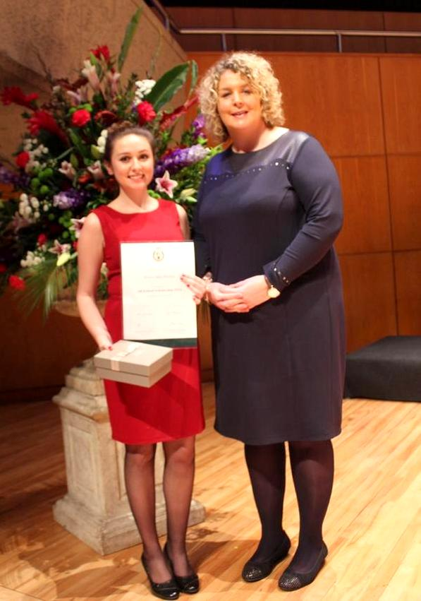

10/11/2014 – String Quartet Workshops for music students.
10/11/2014 – St Mary’s participates in the Mental Health Public speaking Competition. Three TY students presented with Achievement Certificates
12/11/2014 – UCD Scholarhship Awards Ceremony – Ide Kelleher Leaving Cert Student 2014
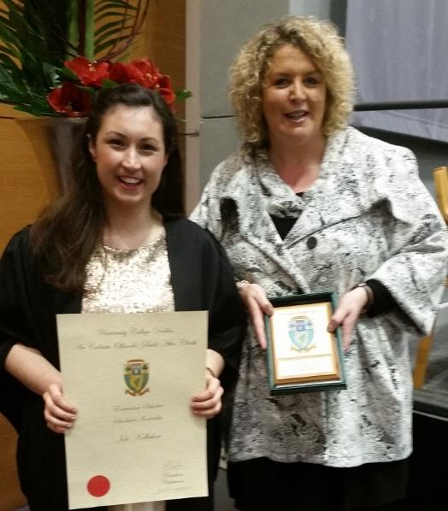

14/11/2014 - Talk to TY students from Mary Crilly Cork Sexual Violence Centre
15th and 16th November – Donna Lyons meets Pope Francis as part of the YSI project 2014-2015 S.T.O.P. Human Trafficking at the first International Anti Human Trafficking Conference in Rome 2014 – see further details in TY section of Report.

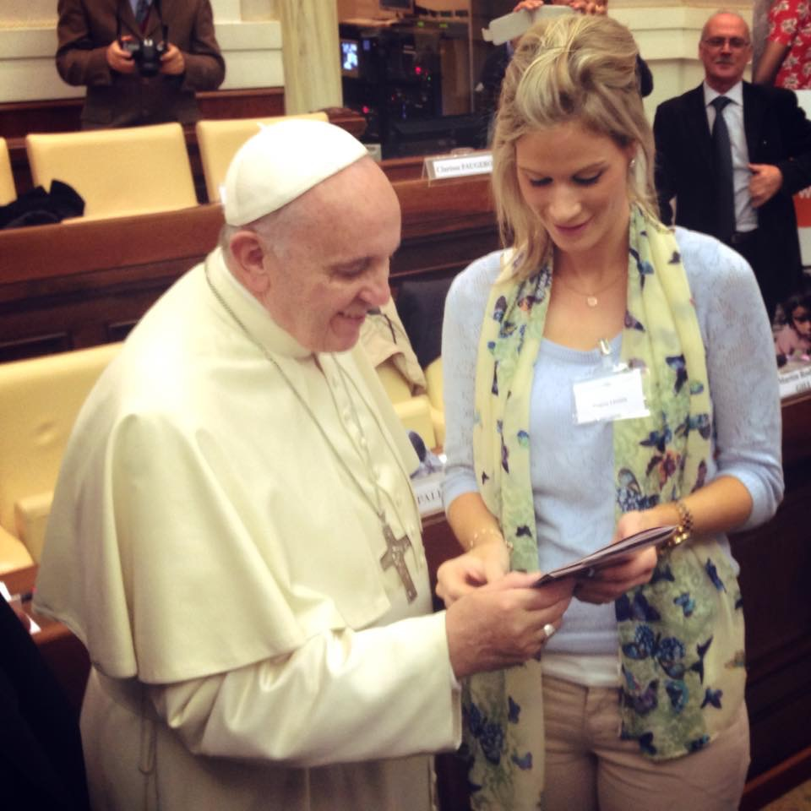

17/11/2014 – Minister Staunton visit to TY year group
20/11/2014 – Nurse Crean – workshop with 1st and 3rd years as part of the SPHE programme.
21/11/2014 – 6th years attend CIT Open Day accompanied by Guidance Counsellors
21/11/2014 – Economics students trip to UCC Economics Department Open Day with Donna Lyons and Valerie O Regan
22/11/2014 – LCA – Fearghal Quinn Awards presented to Becky Relihan LCA 2014
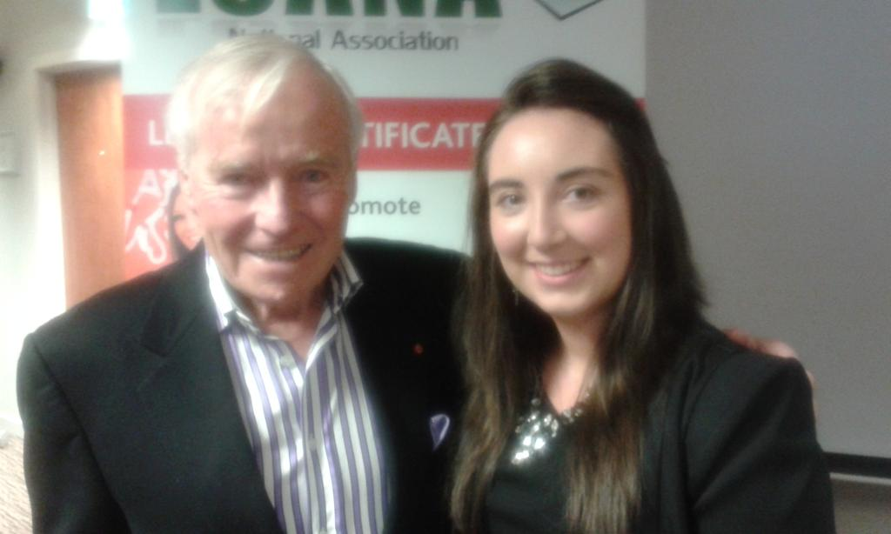

24/11/2014 – Sr Mary Ryan – Act to Prevent Trafficking – talk to TY students
25/11/2014 – Board of Management presentation to retired members of staff Catherine Hourihane and Ann Nyhan and highest Leaving Certificate student Aisling Walsh and LCA student Becky Relihan.
28/11/2014 – President Michael D. Higgins visits Mallow for Thomas Davis celebrations – Senior Choir members perform
1/12/2014 – Christmas German decorations – Lunchtime activity for First years with Fifth year mentors
4/12/2014 – An Evening of Carols – St Mary’s Christmas concert at the Aemilian Theatre
8/12/2014 – St. Mary’s Carol Singing for St Vincent de Paul Christmas Hamper Appeal
8/12/2014 – Senior Students Advent Reconciliation Service

TERM 2:

7th, 8th, 9th, 10th January – Three school projects enter the BT Young Scientist exhibition. Radon project wins its Category award, the Physics Institute Award and the Intel Travel Award. Food in Space project comes 3rd in its Category. Detailed information further in report.
8/1/2015 –2nd years attend the BTYSTE in the RDS Dublin
20/1/2015 – St Mary’s Green Flag Committee Launch Day with Eoin Morton of the Neat Streets Campaign
26/1/2015 – Anti Bullying Charter as part of the revised Anti Bullying Policy on display in all the classrooms
27/1/2015 – Liam Doocey – ‘You don’t have to know it all’ talk for Parents financed by the Parents Association. Liam Doocey also engages 2nd and 3rd years in workshops on bullying/cyber bullying and building resilience.
30/1/2015 – St Mary’s Jersey Day to promote and fundraise for the school Sports Department
10th, 11th and 12th February - Annual TY Musical – South Pacific
23/2/2015 – DCU Entrance Scholarship – Cáit Ní Cheallacháin Rang na hArdteiste 2014

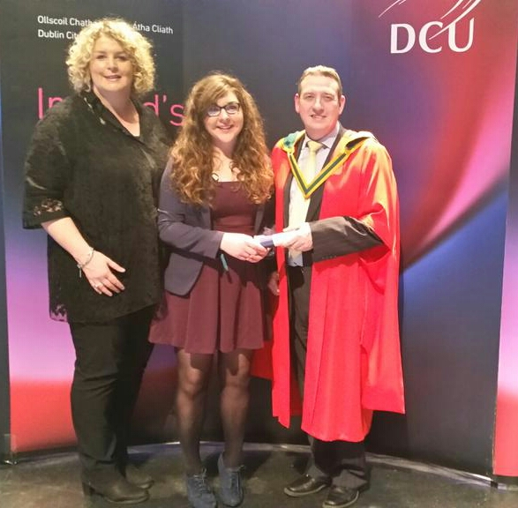

7/3/2014 – Incoming First Years Entrance Assessment
9ú - 13ú Márta 2013 – Imeachtaí na scoile do Sheachtain na Gaeilge
10/3/2015 – Senior Courses and Options information evening for Parents and students.
11/3/2015 – Visit of Japanese Diplomat to St Mary’s
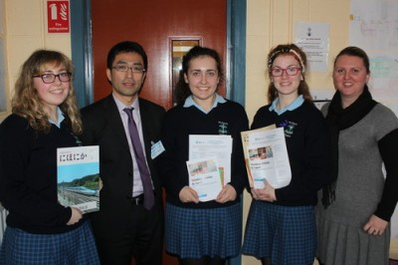

13/3/2015 – St Mary’s participates in the PISA testing 2015
12/3/2015 – St. Mary’s invited to special ceremony celebrating the Irish flag by the Thomas F. Meagher Foundation in Waterford.
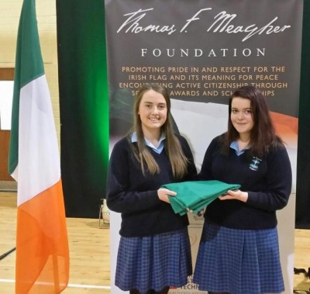

20/3/2015 – Launch of Reading Wall as part of the school’s literacy strategy

24/3/2015 – Three fifth year students; Sandy Balgua, Niamh Fitzpatrick and Emma O Callaghan attend the CEIST student leadership conference in St. Patrick’s College Drumcondra with Ms Úna Griffin

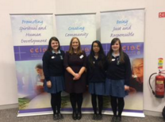

26/3/2015 – Parents Association Table Quiz
27/3/2015 – IT Tralee Apprentice Chef Final Cook off – Emma Buckley TY

TERM 3:

14/4/2015 – TY History Field Trip/ TY Science Trip – Fota House and Gardens
21/4/2015 – 2nd years – RE Trip – Mercy House, Baggot Street, Dublin and Jewish Synagogue
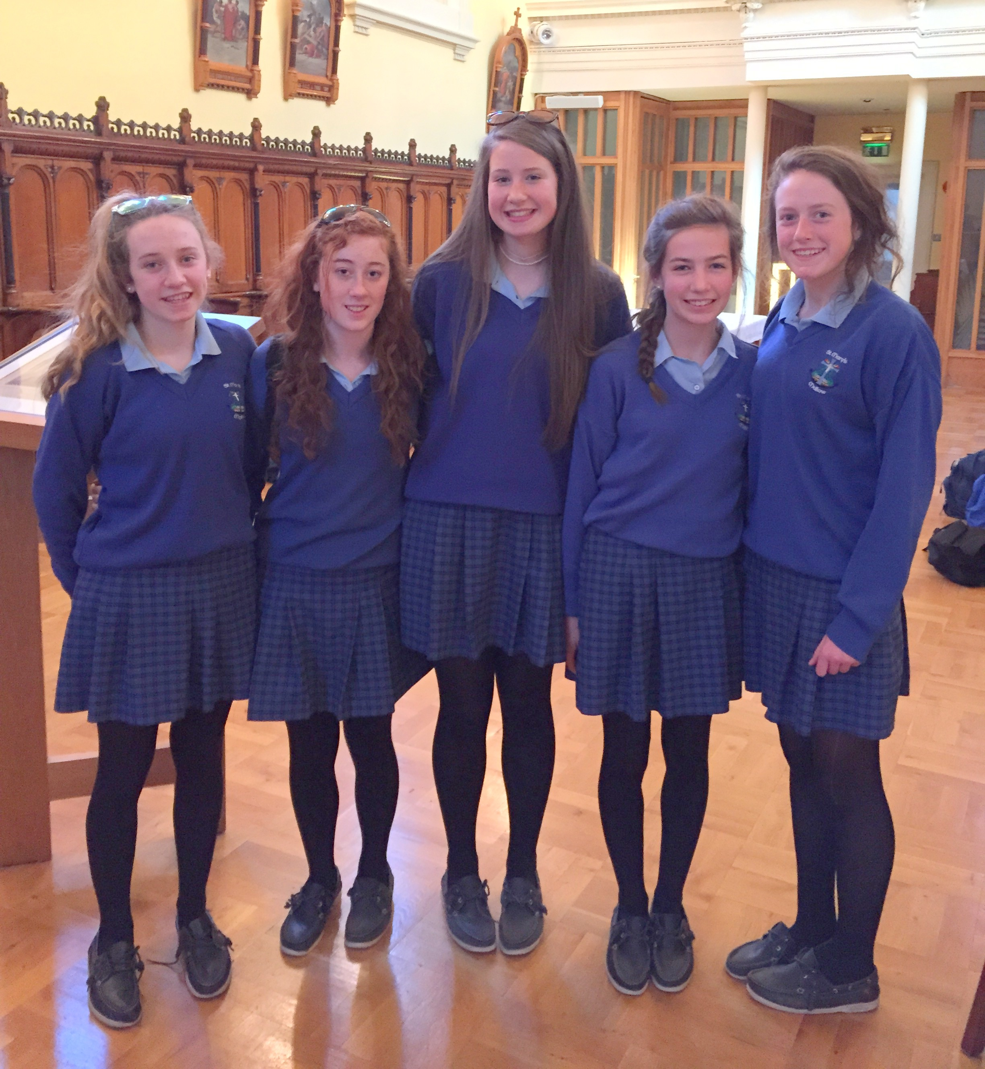

6/5/2015 – Green Schools Committee attend Neat Streets conference in Dublin
6/5/2015 – Young Social Innovators in TY scoop two awards at the YSI showcase – the Social Media Award and the Step – Up Challenge Award
7/5/2015 and 12/5/2015 – TY students visit Ballymalloe Cookery School Co Cork
8/5/2015 – Apprentice Chef Final – Emma Buckley
11/5/2015 – Caoimhe Cronin and Shauna Murphy accompanied by Martin Timmons and Paula Russell attend Intel ISEF in Pittsburgh USA winning two awards; The American Chemical Society award fourth place for innovative research of chemical science, Fourth place in the Chemistry category of grand awards.
12/5/2014 – 2nd year Geography Field trip – Killarney
13/5/2015 – Leaving Certificate Class 2015 Graduation Mass
14/5/2015 – Visit of Jan O Sullivan Minister of Education accompanied by Minister Seán Sherlock

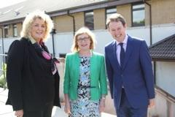

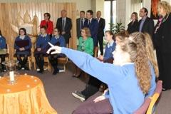

15/5/2015 – LCA 2 End of Year Trip
18/5/2015 – School Awards Ceremony
19/5/2015 – Class Réiltín Trip to Cork
20/5/2015 – TY Graduation
21/5/2015 – TY Japanese trip to Cork

Transition Year :

- Outdoor Pursuits – Cappanlea and Killarney - 15th -19th September 2014
- Mini Company
- Toastmasters
- Rotary Leadership
- YSI – STOP Campaign
The Transition Year YSI group of 2014/2015 stepped up the campaign to raise awareness of human trafficking that had begun with the YSI group of 2013/2014. A successful Colour Run was organised on the 19th October 2014.
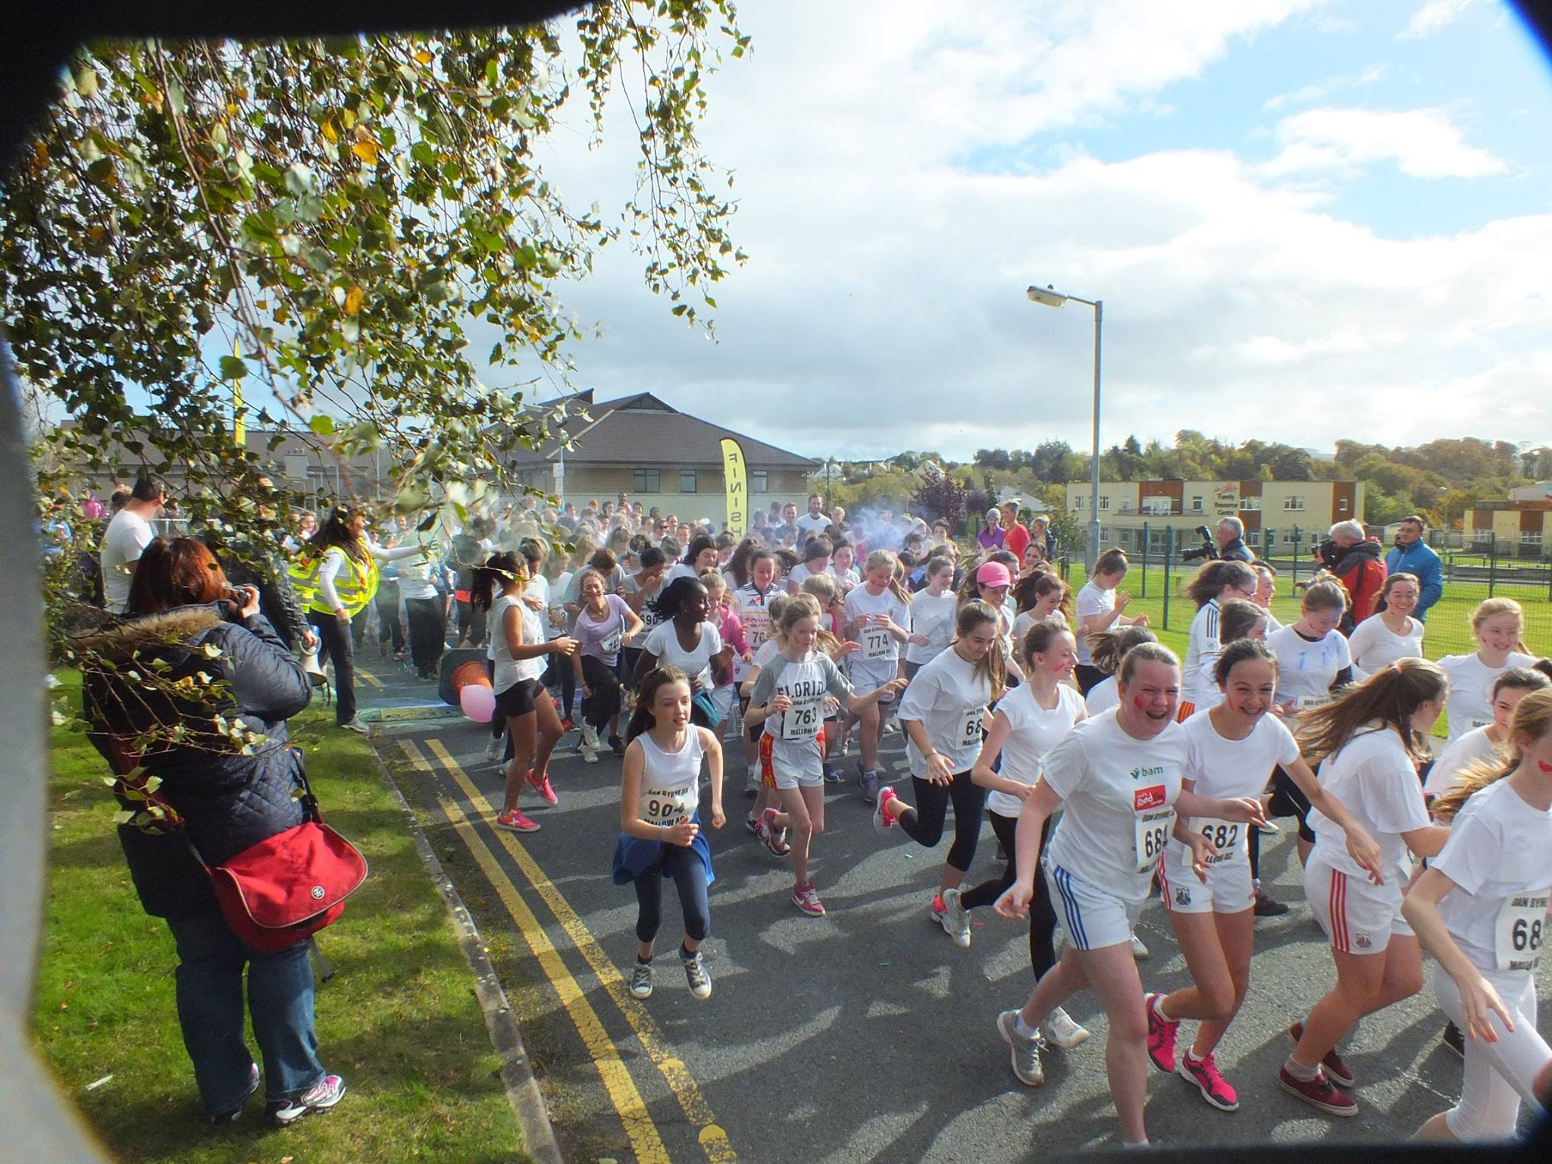

At the first ever International Youth Symposium on Anti Human Trafficking in Rome on the 15th and 16th November 2014 YSI teacher Ms Donna Lyons had the opportunity to meet Pope Francis. At this event she presented him with the information and awareness booklet the YSI class had developed. On the 6th May 2015 this YSI class won two awards at the YSI Showcase 2015. The STOP campaign won the Social Media Award and the Step-Up Challenge Award.

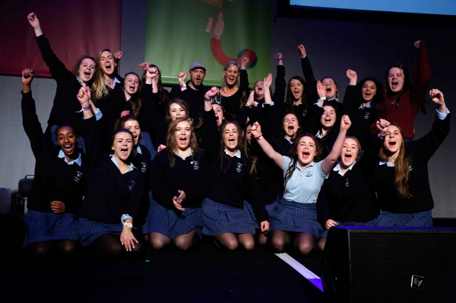

- Hope – Kolkata
Four Transition Year students; Sarah Aherne, Ella Fouhy, Megan Killilea and Tara Murphy travelled to Kolkata in March 2015 visiting various projects run by the HOPE foundation.

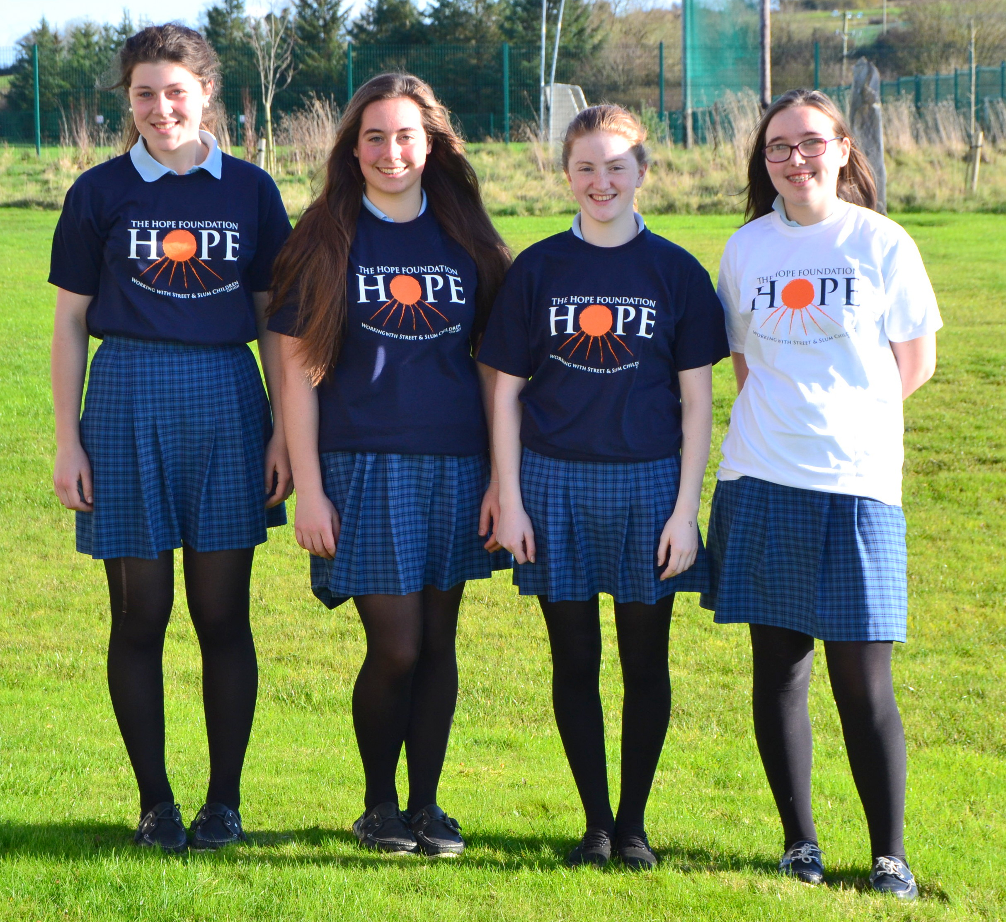
- TY Musical – South Pacific
Transition Year students hit all the right notes with their production of Rodgers and Hammerstein’s musical, ‘South Pacific’. The Aemilian Theatre was the venue for three evening performances on the 10th, 11th and 12th February. The end of each show was met with rapturous applause and a standing ovation. Led by Ms Mary Higgins, Ms Jill Mullins and Ms Maura McAuliffe, the hard work of the previous months was obvious in this energetic and creative production.
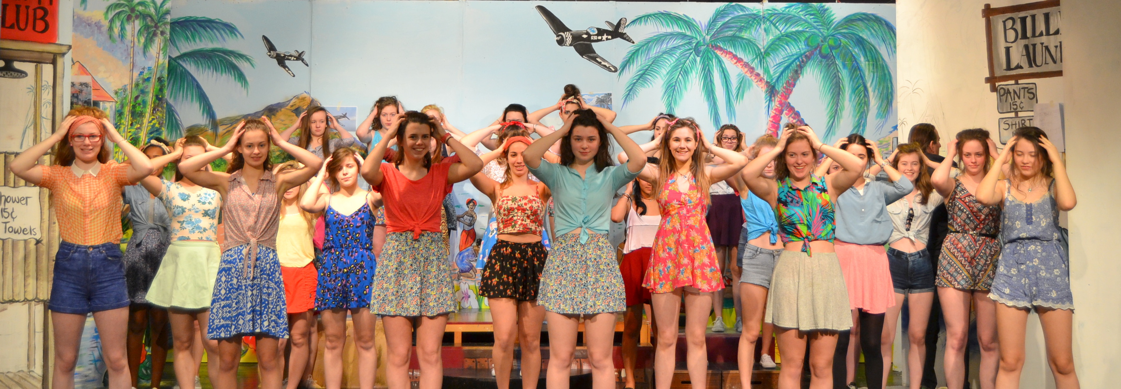

- Debating
- Work Experience
- Community Placement
- St Vincent de Paul fundraising
- Film making
- Mental Health Awareness
- Visit and Talk from JLO with An Garda Siochana 9/9/14
- Build a Bank – Beanstalk Bank
On Wednesday 25th February 2015 the St. Mary’s Beanstalk Bank team participated in the AIB Build a Bank Challenge Regional Finals. With over 33 schools from across Munster involved the students went through a series of interviews detailing the daily running of their bank, marketing techniques, community involvement and digitial strategies. They were awarded the prize for ‘Best Newcomer’ bank.
- Plant a Tree for Me Campaign
Six TY students under the guidance of Ms Carmel Curtin took on ‘One Good Idea’ project aimed at inspiring fellow students to take up the challenge of addressing climate change by planting hundreds of sapling trees.
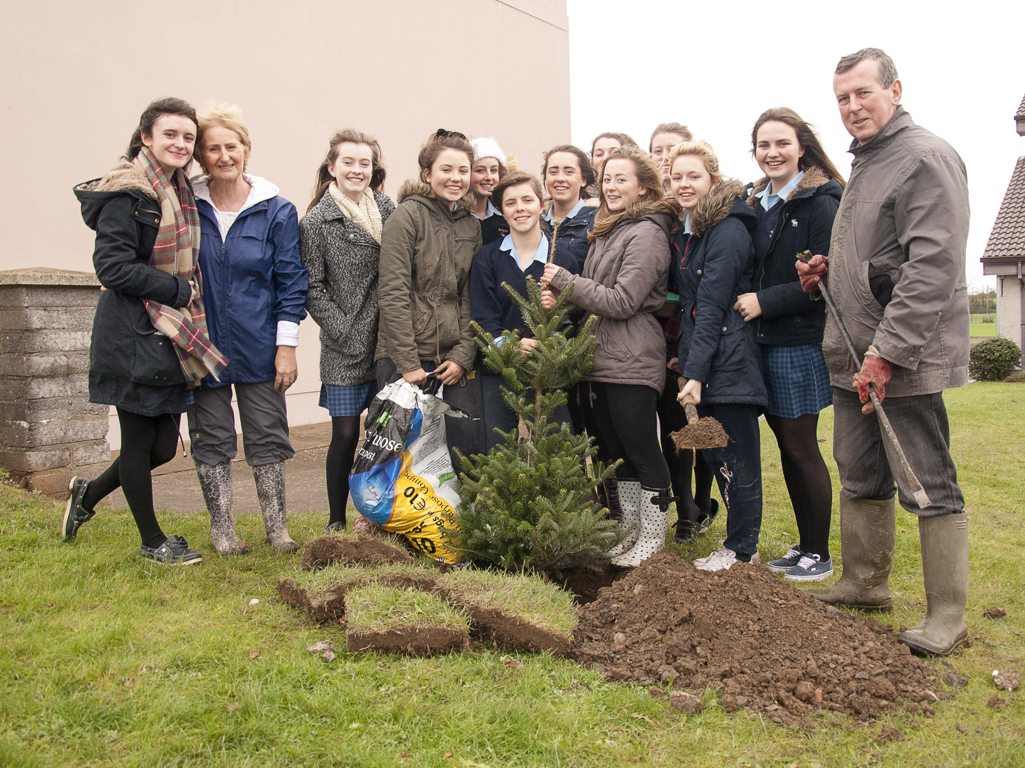

- Silver Surfers
From January 2015 Transition Year students hosted a five week programme to mentor ‘young at heart’ members of the local community on how to use the internet. These Silver Surfers were given the opportunity to receive tutoring on a range of internet enabled devices; smartphones, tablets, laptops and desktop computers. The enthusiastic Transition Years demonstrated how to use the internet for activities such as shopping, banking, entertainment, communication and social media. Apps such as RTE player, Facebook, YouTube, Gmail, WhatsApp and Skype were particularly popular. Each learner was tutored on a one-to-one basis so each silver surfer could work at their own pace.

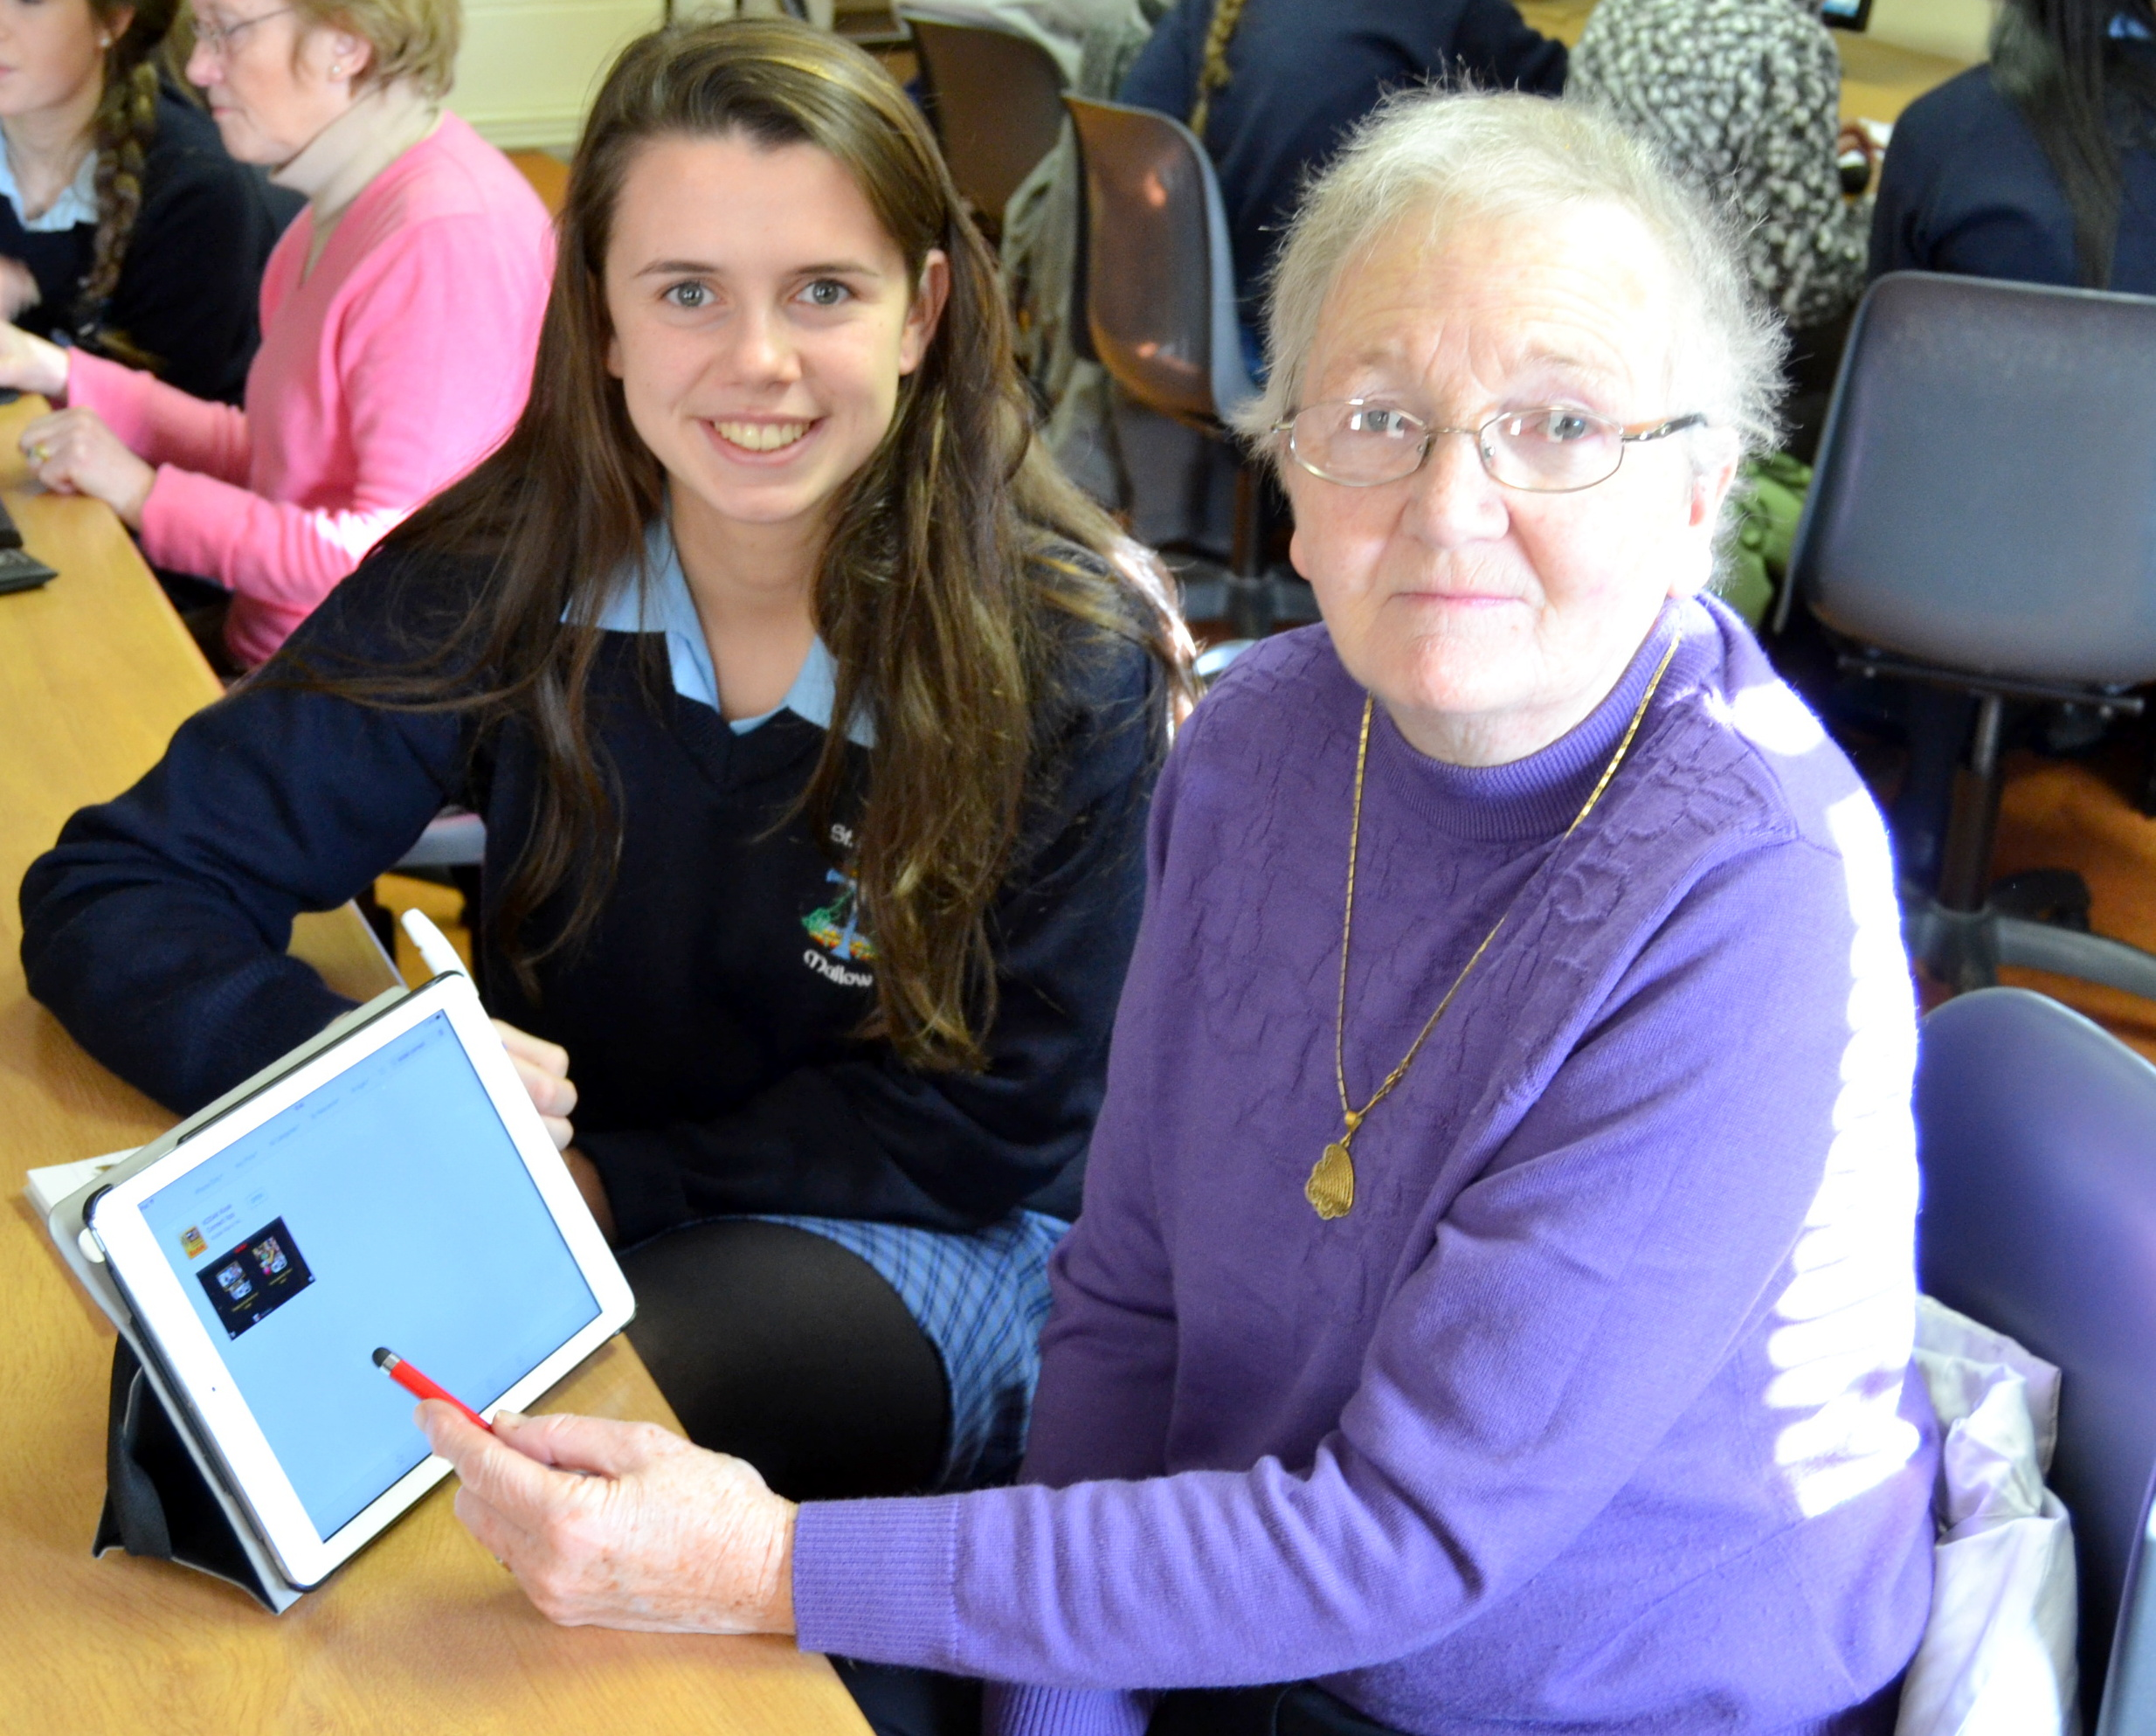

Sports
- Orienteering
- Basketball – All Ireland u 16B schools Cup 2014 winners
- Soccer

- Camogie – FIRST YEAR COUNTY FINAL WINNERS

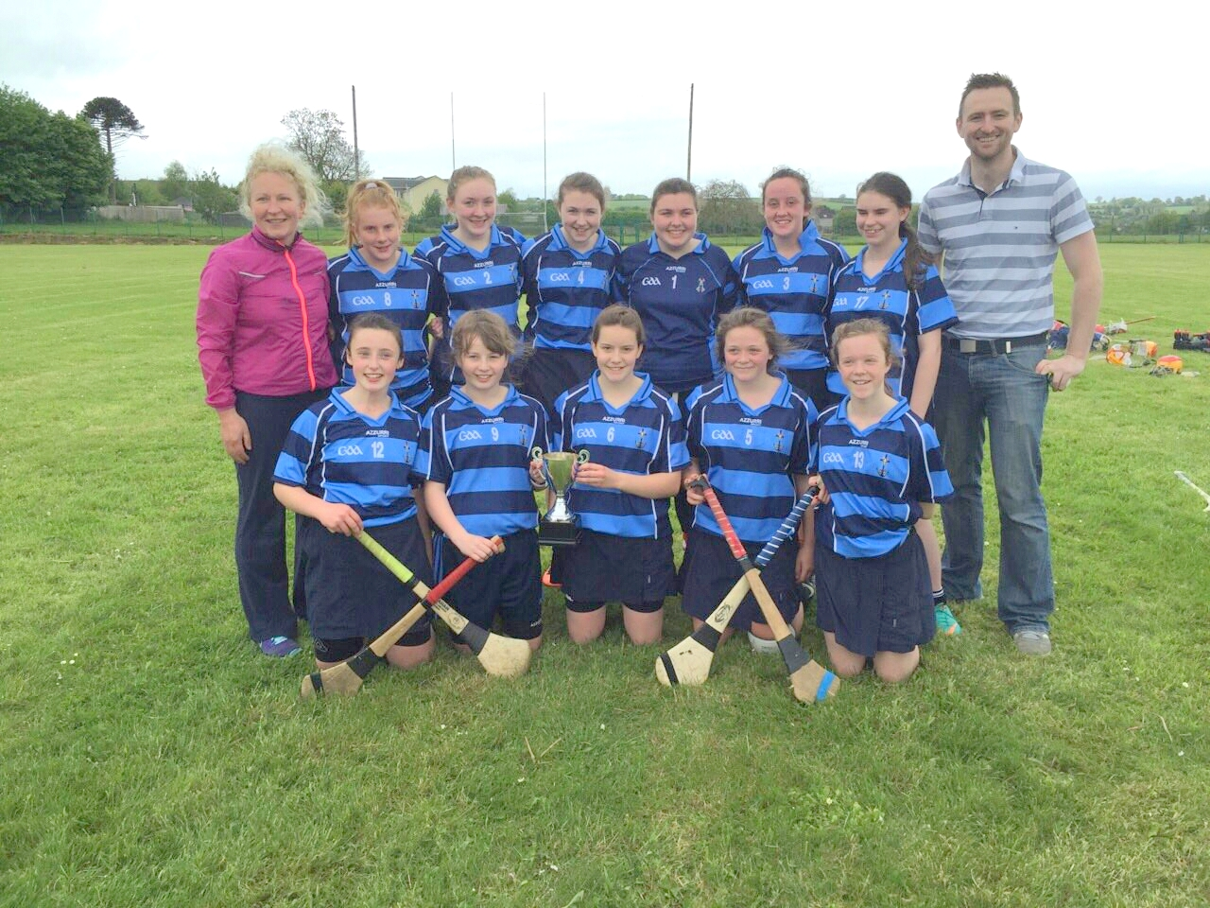

Intermediate Camogie Winners

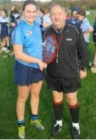

- Gaelic Football
- Rugby
- Horse riding
- Golf

Music

- 1st year Choir
- Junior Choir
- Senior Choir
- Orchestra
- Trad Group

Other

- Christmas Shoeboxes
- Halloween Dance
- French Quiz
- Visit to Crawford Gallery Cork
- Visit to National Concert Hall
- Lá Gaelach
- Young Mercy Leaders – Youth Conference Baggot Street Dublin July 2015
- Pink Day – in aid of Cancer Research
- Games Club on Fridays at lunchtime (new initiative for 14/15 year)

- Green Flag Committee
The school’s first Green Flag committee was established in September 2014. The committee of thirteen junior and senior students was co-ordinated by Ms Aisling O Connor and Ms Aoife Coughlan. The focus for the 2014/2015 year was litter and waste. The students participated in the ‘Bin It!’ and ‘Neat Streets’ workshops. Their blog keeps everyone up to date on events: http://stmarysmallowgreenflag.tumblr.com/
On Saturday 25th April 2015, the community of Mallow was out in force for the annual An Taisce Clean-up. This event was organised by the St Mary’s Green School Committee in conjunction with Mallow Tidy Towns. The guest of honour was international rugby star Heather O Brien. Also present was Eoin Morton of the An Taisce Neat Streets programme.
In recognition of their hard work, representatives fo the committee travelled to Dublin to receive a special Neat Streets Award on 6th May 2015.

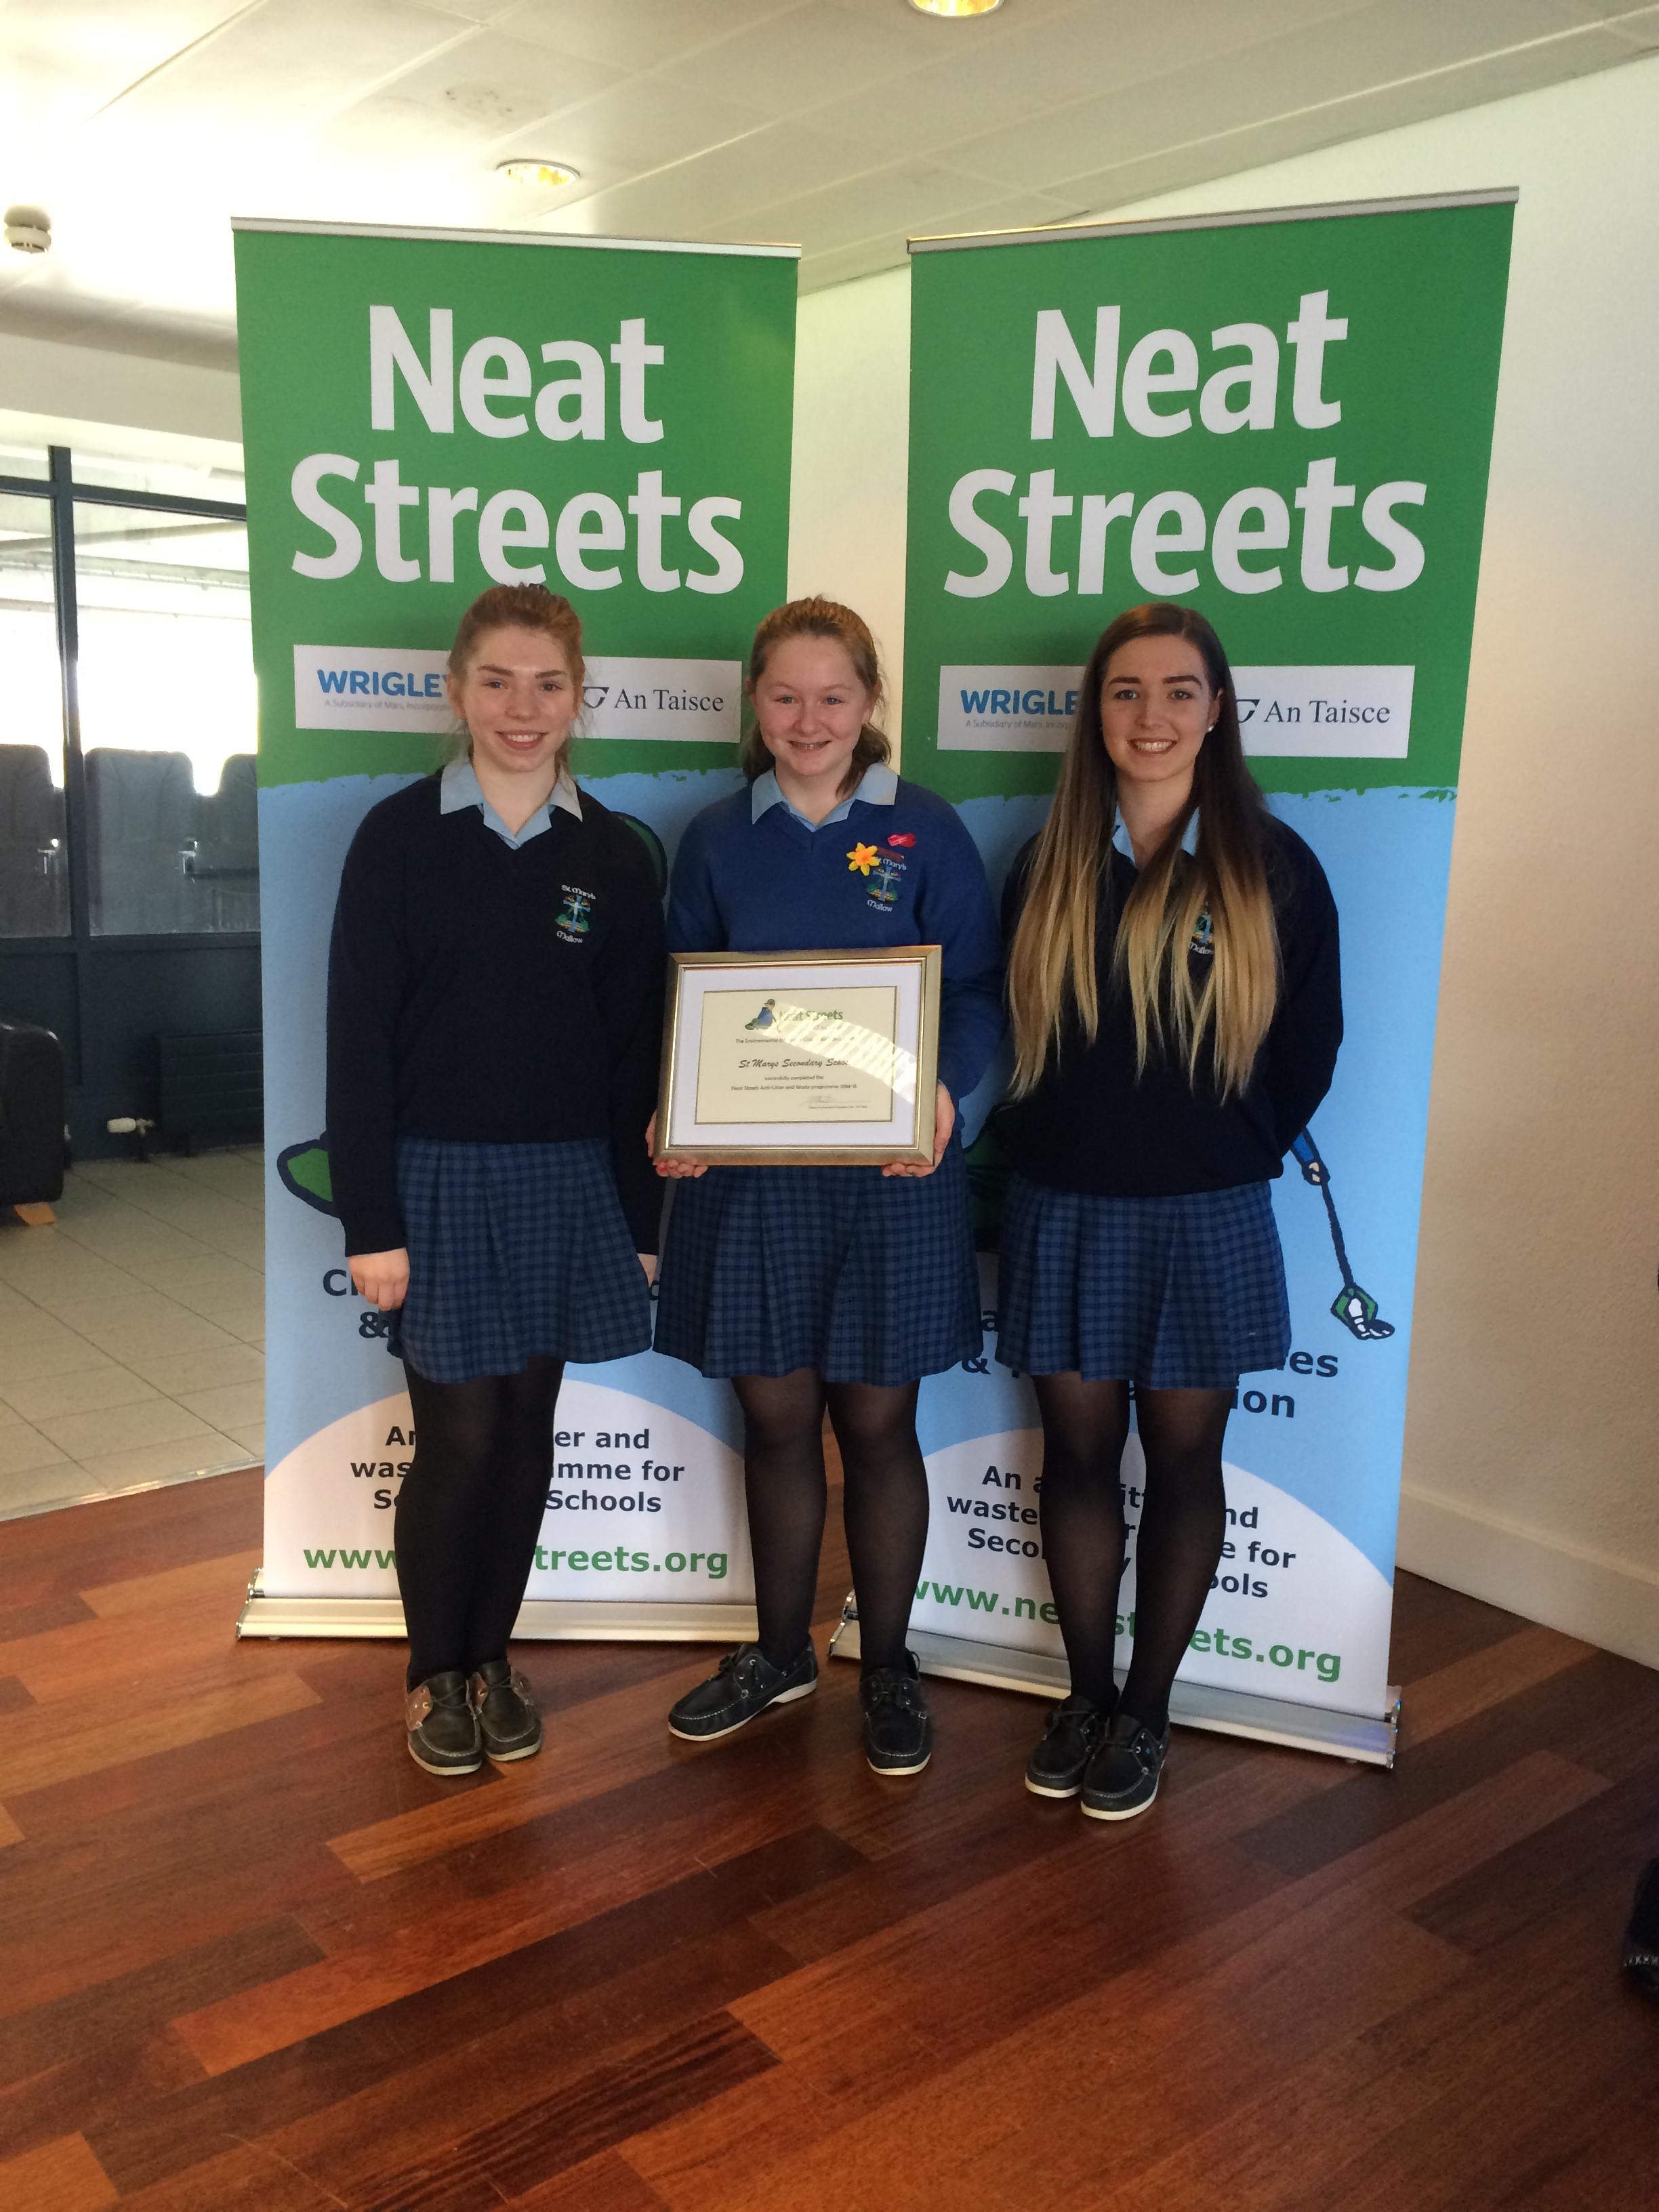

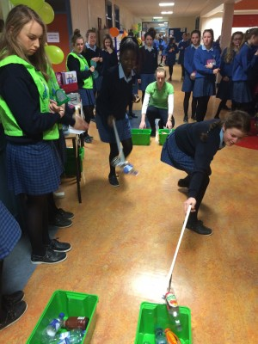

- Health Week
Monday 6th October – Friday 10th October 2014 was St Mary’s Health Week. Students and staff planned a busy week of activities aimed at promoting positive mental and physical health. The PE Department organized an array of physical activities for students and staff. The Sports Hall hosted Taekwondo for Transition Years, Pilates for Fifth Years, Tai Chi for Second years and Zumba for all. The same venue saw the Roinn na Gaeilge host a céilí for all students at lunchtime on Tuesday 7th October.

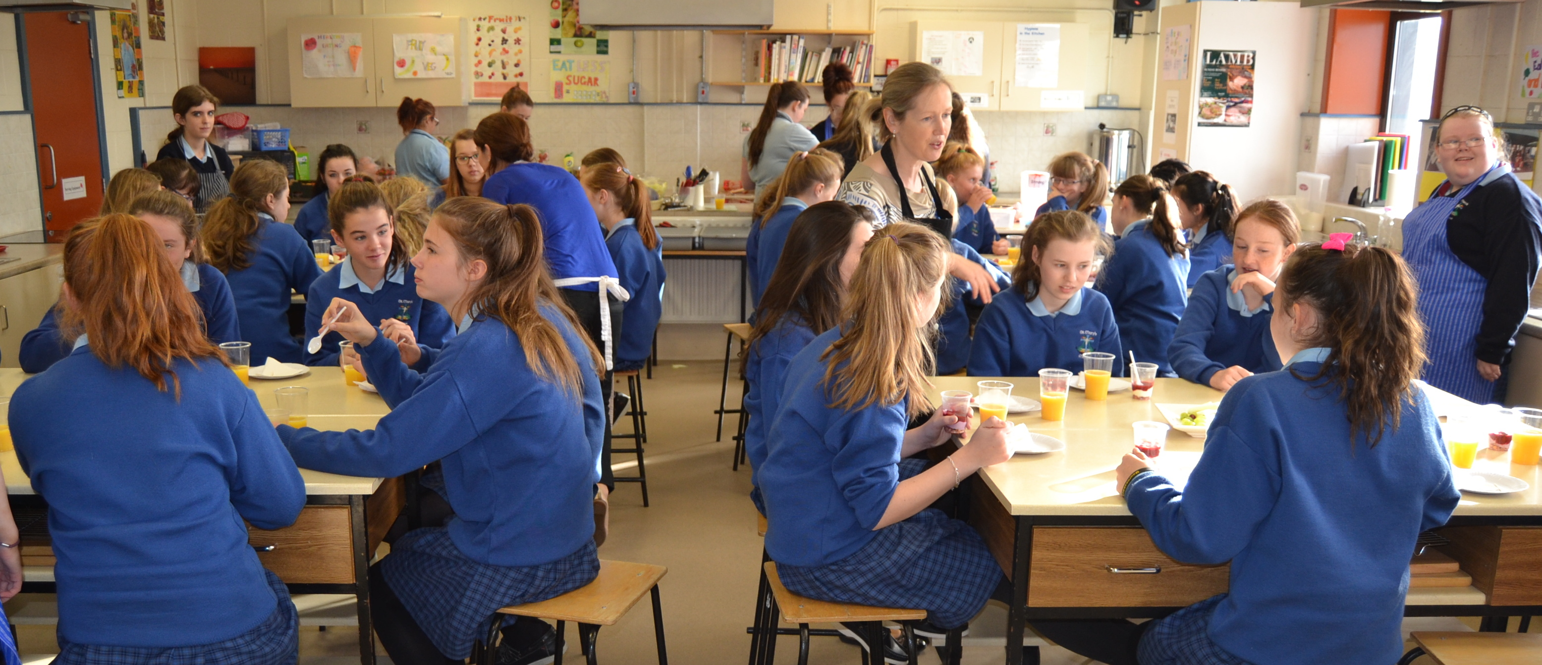
Professor Noel Caplice left a lasting impression as he gave an insightful talk on his role as professor of Cardiovascular sciences at UCC.
One highlight of the week was a Flash Mob organised by the Music Department. Other initiatives included free healthy snacks put together by Home Economics students.

- Thomas Davis Bicentenary

On September 11th 2014, St Mary’s launched a week long Art and History exhibition in Mallow Library. The exhibition was the first in a series of events in Mallow marking the bicentenary of the birth of Thomas Davis. This was a cross curricular event by the History Department (Mr Christian O Connor) and the Art Department (Ms Evelyn Mullen). Pieces on display were the work of Transition Year students. As part of the school’s involvement in the the Thomas Davis Bicentenary celebrations, Ms Mullen and two students traveled to Dublin for the launch of the Thomas Davis bicentenary stamp. The celebrations were brought to a close on November 28th 2014 with a visit from President of Ireland Michael D. Higgins to Mallow to unveil a new statue in the town plaza. Three St Mary’s students performed ‘The West’s Asleep’ at this event.

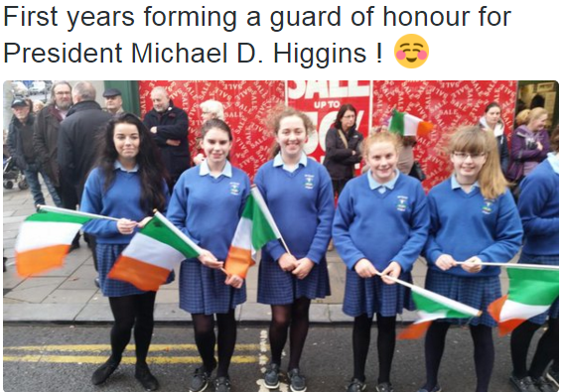

- Seachtain na Gaeilge
Níl aon dabht ach go raibh seachtain iontach ag na daltaí agus na múnteoirí i Scoil Mhuire i rith Seachtain na Gaeilge. Chaith na cailíní ribíní glasa go bródúil agus rinne said a seacht ndíchill labhairt as Gaeilge. Chglac said páirt sa spórt agus sa spraoi a bhí ar súil timpeall na scoile.
Rinne Coiste Gaelach na scoile jab iontach. D’eagraigh said go leor imeachtaí dona daltaí go léir. Bhí can-a-long sa cheaintín, céilithe laistigh agus lasmuigh, tráth na gceist, comórtas litríochta, ealaíne agus cócaireachta, litriú ‘Bee’, slabhra láimhe agus go leor, leor eile. Chuir grúpa cailíní ón gcúigiú blain, a leagan féin den drama ‘ An Triail’ ar an stáitse sam amharclann Aemilian agus a leithéd de bhualadh bos a fuair said ón gcúigiú agus ón séú bliain.
A bhuí lena múinteoirí díograiseacha agus na cailíní iontacha sa scoil, bhaineamar go léir an-taitneamh as an tseachtain.

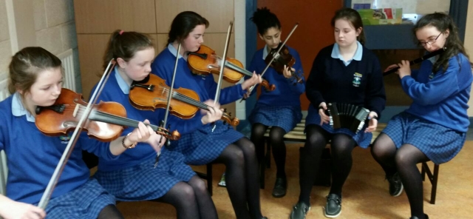

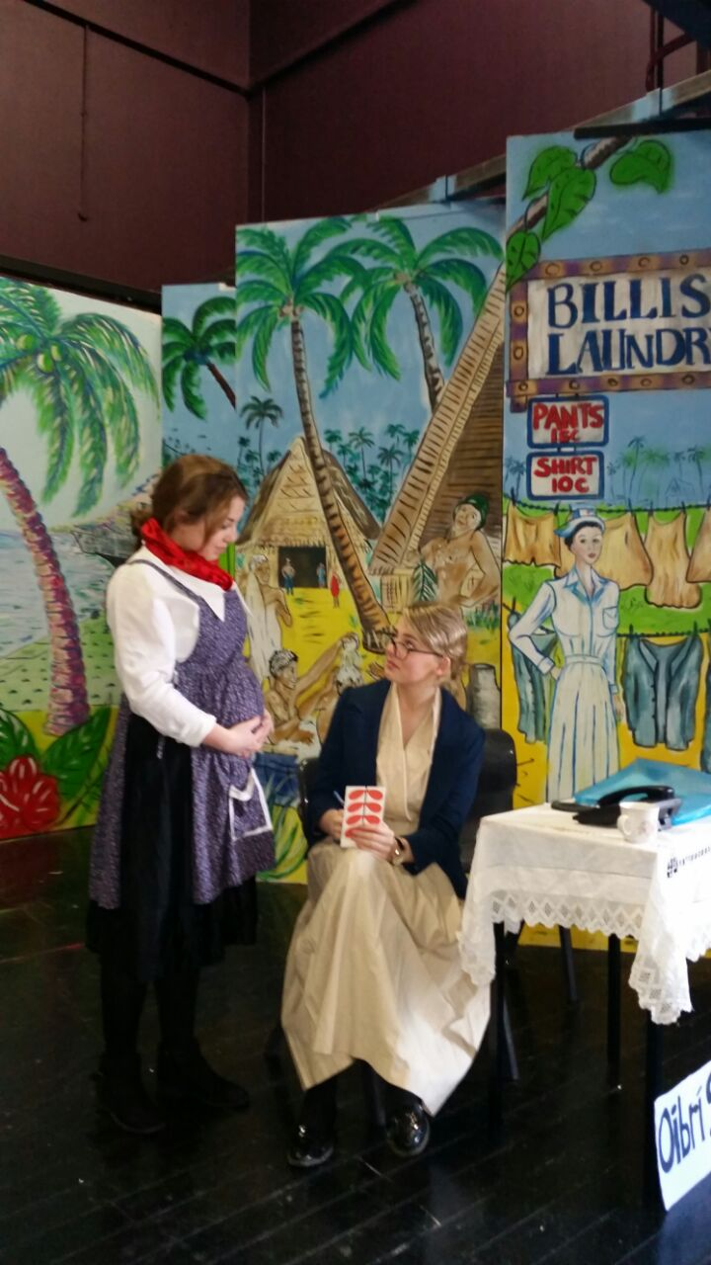

- BT Young Scientist
In January 2015 three projects from St Mary’s entered the BT Young Scientist and Technology Exhibition in the RDS. Caoimhe Cronin and Shauna Murphy scooped three prizes for their Radon Project. They won 1st place Junior Category Chemical, Physical and Mathematical Sciences and were awarded the Physics Institute of Ireland Award as well as the Intel Travel Award to attend the Intel ISEF in Pittsburgh USA. Anna Burns and Eilish Myers won 3rd place Junior Category Biological and Ecological Sciences for their project on Food in Space.
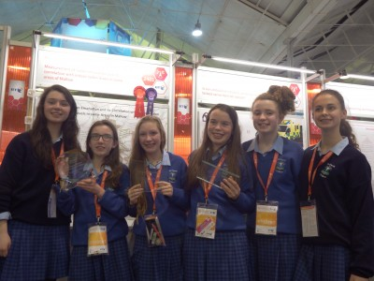

Caoimhe and Shauna continued their winning streak at the Intel International Science and Engineering Fair (ISEF) in May 2014. They won two awards worth $1,500, one from the American Chemical Society for innovative research and a chemistry category fourth place award.

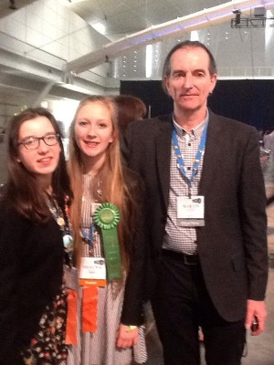

- Continuous Professional Development

The Board of Management and the Senior Management team are committed to supporting the C.P.D. of all staff members. Teaching and learning in St Mary’s Secondary School is enhanced by teacher engagement in Continuous Professional Development. CPD presents teachers with the opportunity to share good practice and develop their understanding and awareness of methodologies in their subject areas as well as allowing teachers to remain up to date with syllabi changes. Subject Departments are also affiliated with Subject Teacher Associations to ensure links with other teachers.

CPD title | Teacher | Date
JMB Education Conference | Yvonne Bane/Una Griffin | 15/9/2014
LCA Inservice | Kim Walsh | 19/9/2014
CEIST Education Conference | Yvonne Bane | 25th and 26th September 2014
JCT – Implementation of Framework for Junior Cycle | Una Griffin | 3/3/2014
PDST National Seminar Leaving Certificate Accounting | Nora O Connor | 26/9/2014
ASD Inservice | Colette O Shea | 3/10/2014
PDST Literacy Cluster | Connie Curtin | 4/11/2014
CAO Conference | Pauline Cudmore | 4/11/2014
PDST Improving Numeracy through SSE | Rory Coote/Úna Griffin | 11/11/2014
Neat Street Conference at the Lifetime Lab | Aisling O Connor/Aoife Coughlan | 19/11/2014
NCSE Conference Dublin | Colette O Shea | 19/11/2014
PDST Anti- Bullying Procedures – Seminar on Awareness Raising, Intervention and Prevention Strategies | Ann Cronin/Úna Griffin | 25/112014
Mind Out Training | Jennifer Hickey | 25/11/2014
NAPD Mike Hughes Workshop | Valerie O Regan/Maria Foley/Noirin O Leary/Nora O Connor | 26/11/2014
Inter school meeting Special Class with Patrician Academy | Jennifer Hickey/Colette O Shea | 27/11/2014
PME Cooperating Teacher Seminar UCC | Mary Brosnan/Dolores Meade | 1/12/2014
Pieta House visit/link re: services | Jennifer Hickey | 1/12/2014
JMB Resourcing Senior Management Teams - Year Head Seminar for Principals and Deputies | Úna Griffin | 10/12/2014
PDST Coursework B – Science Inservice | Denise O Driscoll/Aisling O Halloran/Martin Timmons/Sheena McQuillan | January 2015
LCA Inservice | Mary O Keefe | 15/1/2015
Mind Out Training | Niamh Murphy/Pauline Cudmore | 13/1/2015 and 20/1/2015
PDST Day 2 Improving Numeracy through SSE | Rory Coote/Úna Griffin | 23/1/2015
3rd Annual Literacy Symposium for Teachers – UCC | Niamh Murphy | 7/2/2015
PDST Numeracy Inservice | Valerie O Regan/Rory Coote | 23/2/2015
IGC National Conference – ‘Being positive in Guidance’ | Pauline Cudmore | 27/2/2015 to 1/3/2015
Disability Inclusion Training – CARA and Cork Sports Partnership | Louise Heavin/Marion Roche/Sally Halloran/Siobhan McInerney/Margaret Kiely | 28/2/2015
Network of School Planners Annual Conference – Resilience and support for successful planning | Valerie O Regan/Úna Griffin | 28/2/2015
NAPD Region 7 Annual Conference with Guest Speaker Barrie Bennett | Úna Griffin | 5th and 6th March 2015
Traveller Culture Awareness Training | Pauline Cudmore/Rosemary Flanagan | 10/3/2015
State Examinations Commission Work (Conferences and marking) | Anne Dunne  Valerie O Regan  Maura McAuliffe  Colette Carr  JoAnn O Connor  Mary O Keefe  Carol Heavin  Connie Curtin | 11/3/2015 and 15, 16, 17 April  11/3/2015 and 20/4/2015  23/2/15, 13/3/2015 and 16,17, 20 April  24/3/2015 and Week of: 11/5/2015 – LCA Practicals  20/4/2015  2/2/2015  25/2/2015  26/2/2015
CPD in Psychometric Testing | Pauline Cudmore | 24/3/2015
CEIST Student Leadership Conference (Assistant Facilitator) | Úna Griffin | 24/3/2015
BEdSS PE Cooperating Teachers Seminar | Louise Heavin | 20/4/2015
JMB Conference | Yvonne Bane | 29th April – 1st May 2015
PDST Cluster Meeting – Numeracy | Rory Coote | 5/5/2015
SNA Training with Peggy Ann McCann (Enable Ireland) | Marion Roche/Siobhan McInerney/Sally Halloran/Margaret Kiely | 6/5/2015
Coping With Loss Conference – Nano Nagle Centre | Pauline Cudmore/Mary Brosnan | 20/5/2015
Mallow Second Level Schools Project – Maths – NCE-MSTL (Year 3) | Maths Department | Sept 2014 – May 2015  18/11/2014  9/2/2015  10/3/2015
Mallow Second Level Schools Project – Science- NCE – MSTL (Year 3) | Science Department | Sept 2014 – May 2015  17/11/2014  12/1/2015

- Student Council Report 2014-2015

Each year a student is elected from each class to represent their class on Student Council. We had an extremely busy year and we are very happy with the progress that was made.
- For the first time in the history of the Student Council in St Marys, the vice chairperson was a third year student representative. It was voted by the council that a junior chairperson would be beneficial to both the Council and school business.
- We continued running the successful ‘Common Room’ for 6th year students. This is a classroom which the 6th year students can use at lunch time. There is a fridge and kettle provided in the room. It gives the 6th years an opportunity to meet together and relax!
- We also continued raising awareness for various different activities that was happening throughout the school. We helped the YSI Transition Year class to raise awareness for their Colour Run for their STOP campaign.
- We also took part in both the Open Night for incoming first years and the end of the year Awards Ceremony. We made speeches on both occasions highlighting what the Student Council do in St Mary’s.
- We liaised with both the Principal Ms Yvonne Bane and Deputy Principal Ms Úna Griffin in relation to various problems which arose in the school term e.g canteen prices
- We helped to promote awareness and support of The Green Schools Committee.

- Parental Involvement

Report from Chair of Parents’ Association 2014-2015

The AGM of the Parents Association was held on the 18th September 2014. Some of our long serving parents were gone and we needed to re-organise. Happily Aifric O Grada kept the post of secretary which provided continuity and Michelle Maloney took up the position of treasurer. It was my first year as Chiar and my last year with the Parents Associaion.

We had our annual fundraiser, a Flag Day in November. It was quite successful as a fundraiser with 1100 euro collected on the day.
In January 2015 we organised a talk for Junior Cycle students and their parents. The choice of speaker and themes for discussion were chosen in conjunction with the Year Heads. Liam Doocey spent an afternoon with the students and then spoke to the parents later in the evening.
In March 2015 with great support from the Principal, Yvonne Bane, teachers and TY students, we organised a fun quiz night for Junior Cycle pupils and their parents. It was a great success and was enjoyed by all, including the Parents Assocation.
In June we had a special meeting to consider the updated Code of Behaviour..

This is a brief summary of our activities. It was our first year working with Ms Bane as Principal and I think that a good working relationship has been established.
It was my final year of contact with St Mary’s which began in 2004. Our three daughters all had an excellent experience in the school academically, in terms of their personal development and their experience of the ethos of the school. We are grateful to all the teachers, ancillary staff, Board member and parents association members over the years who all contributed to this.

Signed: Irene Murphy Chairperson, Parents’ Association St Mary’s Secondary School 2014/2015
Date: December 2015

- Report from Chair of BOM

Chairpersons Report for School Year 2014/ 2015

Board of Management

- Philip Comyn, Chairperson, Trustee Nominee
- Bernie Preisner, Trustee Nominee
- Ronan Garvey, Trustee Nominee
- Kevin Myers, Trustee Nominee
- Gerard Smith, Parents’ Nominee
- Carrie Casey, Parents’ Nominee
- Claire O’Farrell, Teachers’ Nominee
- Mairead Lucey, Teachers Nominee.
- JoAnn O’Connor who replaced Mairead Lucey as Teachers’ Nominee on 1/9/2014.

School Principal Yvonne Bane attended as Secretary to the Board. The Board met on 10 occasions during the year and each meeting lasted upwards of 2 hours or more.

Those priority areas identified at the first meeting of this Board in October 2014 which had not been resolved by the end of school year 2013/ 2014 continued to form the agenda for meetings held throughout the school year and items as necessary were added to the agenda.

The areas covered included the following.

- Finance. The finance sub-committee continued to meet on an ongoing basis. This subcommittee reported in turn to the Board on a regular basis. The representative from Messrs. O’Brien Cahill & Co Chartered accountants attended one of the meetings at which annual accounts were discussed at length and approved.
- School Maintenance. The main areas concerned are storage space for students and in particular the locker areas. Additional shelving was put in to alleviate this problem and is successful. Considerable painting and general maintenance was carried out to the school.
- Board of Management Training. The Chairman attended a number of Seminars in particular on legal issues affecting schools and also financial guidelines.
- School Awards Ceremony. Dr. Marie Griffin CEO of CEIST. Dr. Marie Griffin on behalf of CEIST presented the spirit of CEIST award. Members of the Board of Management also presented awards to both present and past students and supported the work of staff, students and parents at the various ceremonies. Contact was maintained with the Parent’s Association throughout the year and an agreed report from each meeting of the Board was presented to the Parents’ Association.
- School Self Evaluation Process. The literacy strategy was finalised by the teachers and presented to the Board. The Board of Management acknowledged the role played by the staff in the completion of this support.
- School Achievements. Three projects were entered for the BT Young Scientists of the year award and were awarded four prizes. One entry won the Intel Award and subsequently the students represented the school at the Intel ISEF Conference in Pitssburgh USA. The Young Social Innovators won two prizes at the National Showcase. Students won prizes in a wide range of areas including sporting, literacy, academic and culinary. The Board of Management acknowledge the hard work of staff, students and parents in gaining these achievements.
- Fundraising. Substantial funds were again raised by the school Fundraising activities included a golf classic, Christmas Concert, , TY Musical, Table Quiz, and Cake sales to name but a few.

As Chairperson I would also like to acknowledge the hard work and assistance given to me by the Board Members and the Principal Yvonne Bane.

Dated the 15th day of December 2015

Signed: Philip Comyn – Chairperson Board of Management

- Enrolment

Enrolment for the 2014-2015 year was 552.
The following enrolment criteria is followed as per the school’s enrolment policy:
We enrol up to 4 classes of not more than 30 pupils in each in First Year. In the case of oversubscription the Board of Management will take cogniance of the following criteria for admission (which are not in order of priority):
- Religion
- Feeder Primary Schools – Killavullen, Dromahane,Glantane, Ballyclough, Baltydaniel, Scoil Ghobnatan, Gaelscoil Thomais Daibhis, Rathan, Mallow No.1, Burnfort, Analeentha
- Sisters of present students
- Children of BOM employees
- Children whose mothers are past pupils
- Random selection in the case of exceeding 120 applicants in First Year or of the overall enrolment exceeding 590.

Application Procedure:
In September 2014 the Deputy Principal (Úna Griffin) and the Principal (Yvonne Bane) visited the feeder Primary schools accompanied by current students from different year groups. These visits were arranged in collaboration with the Primary School Principals so as to cause as little disruption to the teaching day for 6th class girls as possible. A short presentation was made to the 6th class girls and each student was given an enrolment form as well as a letter of information outlining the details of the upcoming Open Night.
The Open Night was held on 1st October 2014 for 6th class girls and provided the prospective students with the opportunity to experience school life in St Mary’s and participate in a variety of activities. A presentation to parents was made in the Sports Complex and involved a gymnastics display, a sporting display and a musical interlude as well as brief presentations from the Student Council, Parents’ Association, the Principal and the Deputy Principal.

The Entrance Assessment took place on 7th March 2015. For the first time St Mary’s administered Psychometric Tests and a school based Irish exam as part of the Entrance Assessment. This was done in line with DES recommendations on gathering data and ensuring needs of students of all levels are catered for.
The parents of each student were met individually in May 2014 by a member of a team comprising the Principal (Yvonne Bane), Deputy Principal (Úna Griffin), Guidance Counselors (Jennifer Hickey and Pauline Cudmore) and Learning Support Teacher (Colette O Shea). Each parent received a copy of the revised (2015) Parent Handbook, including our Code of Discipline.

St Mary’s endeavours to meet the challenges regarding enrolment positively. There are a number of schools in the locality providing 2nd level education to girls but St Mary’s is the only all-girls school and prides itself on this.
The mission statement and the CEIST charter form a central part of promoting the unique teaching and learning environment that is St. Mary’s. Staff work together in promoting the school through the Newsletter (first published in December 2014), the updated school website, local media, social media including Twitter (new account established 2014/2015 year).
Where challenges do exist and have been highlighted include:
- Accommodating students in our canteen area as it is not big enough to cater for the number of students eating in the school at lunchtime.
- We have no suitable space/room for oral exams/taping and have had to rent additional space in the Mercy Centre in the past.
The Board of Management will apply to the DES for building grants to provide for additional requirements as and when they are available.

2014-2015 – St. Mary’s Secondary School, Mallow.

Ní neart go cur le chéile

Class Réiltín December 2014

